THE WORLD OF GENERATIVE AI

AI FOR INNOVATION
AI for Enterprise
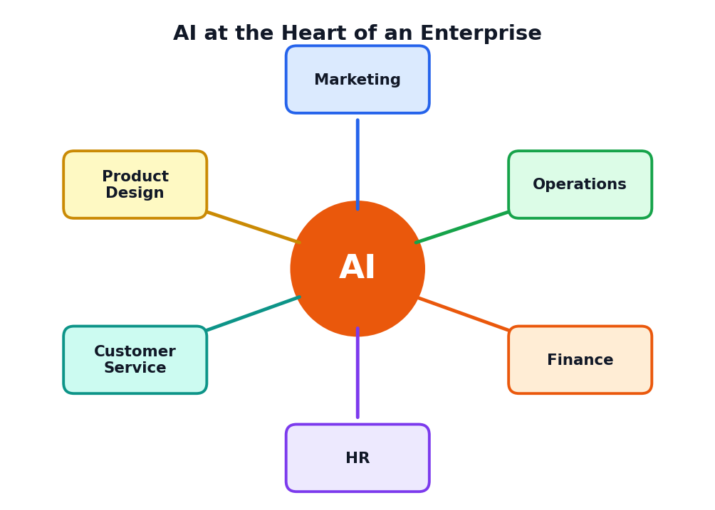
A Student Course Book
Class 12 | One-Month Course
Simple language, real examples, pictures and practice

About This Book
Read this page first
Welcome to AI for Innovation: AI for Enterprise. This book belongs to the course The World of Generative AI. It explains how businesses and organisations, called enterprises, use Artificial Intelligence (AI) to create new ideas, improve their work and serve people better.
You may think AI is only for big technology companies. In fact, a small tea shop, a hospital, a farm cooperative, a bank, a school and a factory can all use AI in some way. This book shows you how, using simple words, pictures and examples.
Figure 0.1: AI can support every part of an enterprise

Who is this book for?
This book is written for Class 12 students. You do not need to know programming or advanced mathematics. If you can read, think and ask questions, you can understand everything here. Difficult words are explained in the text and again in the Glossary at the end.

What will you be able to do after this course?
- Explain what innovation is and name its four types.
- Describe how AI helps innovation through speed, scale, insight and creativity.
- Understand what an enterprise is and how its departments work together.
- Give examples of AI use in marketing, sales, operations, HR, finance and service.
- Explain why data is important and what makes data good.
- Describe the stages of an AI project from problem to improvement.
- Use simple innovation methods such as design thinking, prototypes and pilots.
- Judge an AI idea for value, cost, risk and ethics.
- Plan a small AI innovation project of your own.

How to use this book
- Read one chapter at a time. Each chapter begins with goals and ends with a summary.
- Study every picture. Pictures are part of the lesson.
- Do the Activity boxes. They turn ideas into skills.
- Remember that company names in examples are imaginary, so you can focus on ideas.
- Finish the practice questions in Chapter 16 and the project in Chapter 15.

What the coloured boxes mean
KEY IDEA
A big idea to remember for exams and for real life.

TIP
A helpful shortcut or good habit.

CAREFUL
A common mistake or risk.

EXAMPLE
A sample situation that shows the idea at work.

ACTIVITY
A task for you to try, alone or with friends.

Contents
What you will find in this book
Chapter | Title | What you will learn
1 | What Is Innovation? | Meaning, types, the innovation cycle
2 | AI as an Engine of Innovation | How AI helps people create better things
3 | What Is an Enterprise? | Kinds of organisations, departments, value chain
4 | AI in the Enterprise: Overview | Use-case map, levels of AI use, human and AI roles
5 | AI in Marketing, Sales and Customer Service | Personalisation, forecasting, chatbots
6 | AI in Operations and Supply Chain | Demand prediction, quality checks, maintenance
7 | AI in HR, Finance and Administration | Hiring, training, fraud alerts, reports
8 | AI Across Industry Sectors | Healthcare, banking, farming, education, retail, transport
9 | Data: The Fuel of Enterprise AI | Data types, data quality, data pipeline
10 | Building an AI Solution | The six-stage AI project life cycle
11 | Innovation Methods | Design thinking, idea funnel, prototype, pilot
12 | Strategy, ROI and Change Management | Costs, benefits, KPIs, helping people adopt AI
13 | Responsible AI and the Future of Work | Privacy, fairness, security, jobs and skills
14 | Startups and Entrepreneurship with AI | From idea to one-page business plan
15 | Case Studies and Final Project | Five worked cases and an Innovation Challenge
16 | Practice Questions | MCQs, short and long answers, answer key
17 | One-Month Learning Plan | Weekly schedule and assessment ideas
 | Glossary and Quick Revision | Key words and one-page summary

CHAPTER 1

What Is Innovation?
Understanding new ideas that create real value
CHAPTER GOALS
- Explain the meaning of innovation in simple words.
- Tell the difference between invention, creativity and innovation.
- Name and explain four types of innovation.
- Describe the five steps of the innovation cycle.

1.1 The Meaning of Innovation
Innovation means turning a new idea into something useful that people actually use. The idea may be a new product, a better way of working, a new service or a new way of earning money. The important word is useful. An idea that stays in a notebook is not yet an innovation.
Think about how people used to buy train tickets by standing in a long queue at a counter. Then online booking arrived. Today you can book a ticket on a phone in two minutes. That change, from queue to phone, is an innovation because it saved time and made life easier for millions of people.

1.2 Creativity, Invention and Innovation
Word | Meaning | Example
Creativity | Having new and original ideas | Imagining a bag that charges your phone
Invention | Making something completely new for the first time | Building the first working model of that bag
Innovation | Making an idea useful and used by many people | Selling the bag so that thousands of students use it daily

KEY IDEA
Creativity gives the idea, invention builds it, and innovation brings it to people and creates value.

1.3 Why Is Innovation Important?
- It solves problems such as long waiting times, high costs and unsafe work.
- It helps businesses survive. Companies that never improve are replaced by those that do.
- It creates jobs. New industries and services need new skills and workers.
- It improves daily life with better health care, travel, learning and communication.
- It helps the country grow by making work more efficient and creating new products.

1.4 Four Types of Innovation
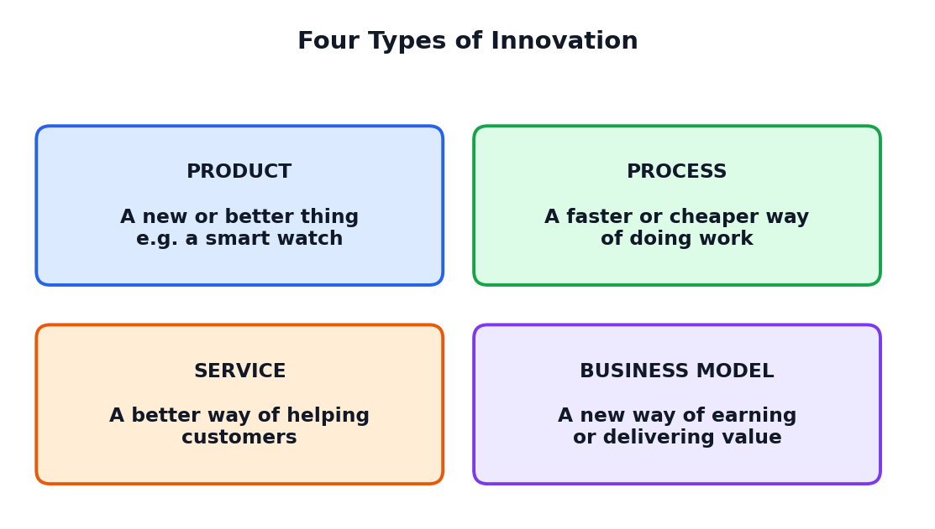
Figure 1.1: Four types of innovation
Type | What changes | Example
Product innovation | A new or improved product | A water bottle that reminds you to drink
Process innovation | A better way of doing work | A factory using cameras to find faulty items quickly
Service innovation | A better way of helping customers | A bank that answers questions at any hour
Business model innovation | A new way to earn or deliver value | Renting a machine by the hour instead of selling it

1.5 Small and Big Innovations
Innovation does not always mean something huge. Incremental innovation means small improvements, such as making an app easier to use. Radical innovation means a big change that creates a new way of living, such as the mobile phone replacing many separate devices. Both are valuable. Most organisations improve every day through many small steps.

1.6 The Innovation Cycle
Innovation usually follows a cycle of five steps. The cycle repeats, because every launch teaches something new.
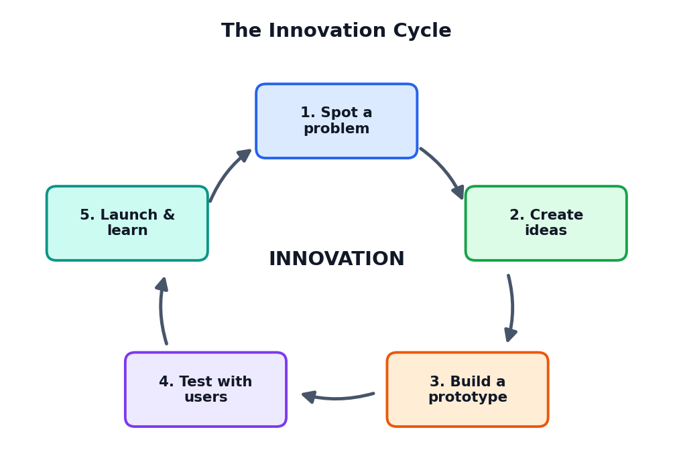
Figure 1.2: The innovation cycle
Step | Question to ask | Example: a school library
1. Spot a problem | What is difficult or slow for people? | Students cannot find books quickly
2. Create ideas | How could we solve it in many ways? | Better labels, a search app, a helper robot
3. Build a prototype | Can we make a quick small version? | A simple search page on one computer
4. Test with users | Do people find it useful? | Ten students try it and give opinions
5. Launch and learn | What should we improve next? | Add Tamil search and a map of shelves

ACTIVITY 1.1: SPOT THE PROBLEM
Walk around your school or home and list five small problems (for example: crowded canteen queue, hard-to-find notices, wasted paper). Choose one and write how you could solve it in two different ways.

1.7 Barriers to Innovation
- Fear of failure: people avoid trying new things.
- Lack of resources: money, time and tools may be limited.
- Resistance to change: many people prefer the old way.
- Not listening to users: building something nobody needs.
TIP
Great innovators fail many times on the way. Each failure is information that helps the next try.

1.8 Chapter Summary
- Innovation is turning a new idea into something useful that people use.
- Creativity makes ideas, invention builds something new, innovation spreads the value.
- Four types: product, process, service and business model innovation.
- The innovation cycle: spot a problem, create ideas, prototype, test and launch and learn.
CHAPTER 2

AI as an Engine of Innovation
How Artificial Intelligence helps people create better solutions
CHAPTER GOALS
- Recall what AI and generative AI are.
- Explain four ways AI supports innovation.
- Understand where humans are still needed.
- See how AI changes each step of the innovation cycle.

2.1 AI in Simple Words
Artificial Intelligence (AI) means computer systems that can perform tasks that usually need human intelligence, such as understanding language, recognising images, finding patterns and making predictions. Generative AI is a kind of AI that creates new content: text, images, music, video and computer code.
AI learns from large amounts of data. For example, if an AI system sees thousands of photos of ripe and unripe mangoes, it can learn to tell them apart. If it reads huge amounts of text, it can learn to write sentences in a human-like way.

2.2 Four Ways AI Helps Innovation
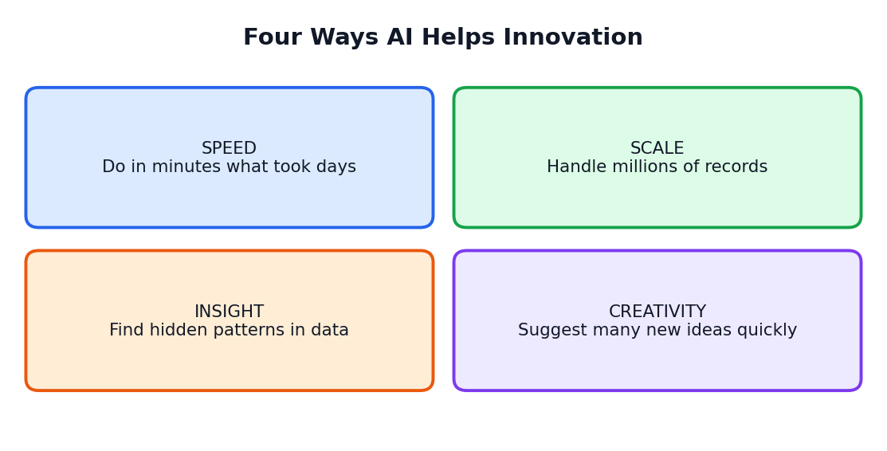
Figure 2.1: Speed, scale, insight and creativity

1. Speed
AI can finish routine tasks in seconds: summarising a long report, sorting thousands of emails, or creating ten drafts of a poster. This frees people to spend time on thinking and decisions.

2. Scale
A person may read a hundred customer reviews in a day. An AI system can read a million. When an enterprise serves many customers, AI helps it handle large numbers without losing quality.

3. Insight
AI can spot patterns in data that humans may miss. A shop owner may see that umbrellas sell more on certain days; AI can connect sales with weather, festivals and prices to predict demand more exactly.

4. Creativity
Generative AI can suggest many ideas quickly: product names, slogans, designs, story plots or experiment ideas. You can then pick, mix and improve the best ones. AI does not replace human imagination but gives it a fast start.

2.3 AI and the Innovation Cycle
Innovation step | How AI can help | What humans must do
Spot a problem | Analyse customer feedback and data for common complaints | Understand real people; decide which problem matters most
Create ideas | Generate many ideas and variations | Choose ideas that fit values, needs and resources
Build a prototype | Draft designs, text, images or sample code | Decide quality; test with real users
Test with users | Summarise feedback; find patterns | Talk to people; notice feelings AI may miss
Launch and learn | Track results and suggest improvements | Make final decisions; take responsibility

2.4 Humans and AI: Different Strengths
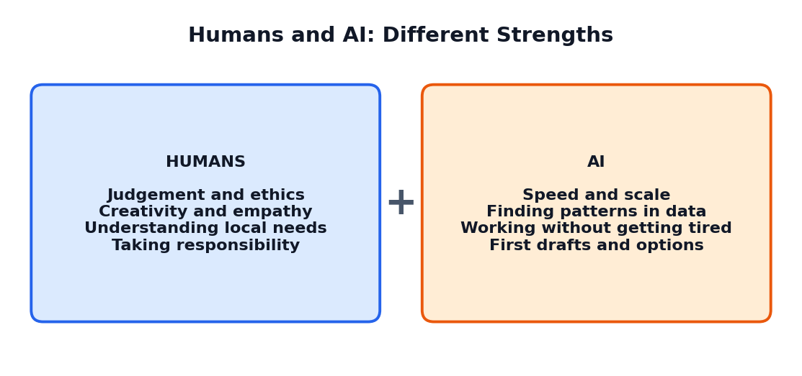
Figure 2.2: The best results come from humans and AI working together
KEY IDEA
AI is a powerful assistant for innovation, not a replacement for human judgement, creativity and ethics.

2.5 Limits of AI Innovation
- AI can be wrong. It may state false facts or make poor predictions.
- AI depends on data. Poor or unfair data leads to poor or unfair results.
- AI lacks real understanding of people. It does not feel the needs and emotions of customers.
- AI can be misused for cheating, false news or privacy violations.
- AI needs people to decide goals. It does not know what is important unless we tell it.
CAREFUL
A tool that makes a task fast is not always making a good decision. Always check important AI results with human judgement.

2.6 An Everyday Example
IMAGINARY EXAMPLE: GREEN LEAF TEA SHOP
Green Leaf is a small tea shop. The owner uses a free AI tool to suggest names for three new tea flavours, writes short offers for the festival season, and summarises customer comments from a suggestion box. The owner still decides the final names, tastes every tea and talks to customers. The shop becomes more creative without needing a big budget.

ACTIVITY 2.1: AI FOR MY SCHOOL
Think of one task in your school (such as making notices, planning events, or answering parents' questions). Write how AI might help with speed, scale, insight or creativity. Then write one thing that humans must still do.

2.7 Chapter Summary
- AI performs tasks like pattern finding, prediction and content creation using data.
- AI helps innovation through speed, scale, insight and creativity.
- Humans still provide goals, empathy, judgement and responsibility.
- AI has limits: it can be wrong, biased or misused, so checking is necessary.
CHAPTER 3

What Is an Enterprise?
Understanding organisations, their departments and how they create value
CHAPTER GOALS
- Explain what an enterprise is and name different kinds.
- Describe the main departments and their jobs.
- Understand the value chain.
- Learn why enterprises need to innovate.

3.1 The Meaning of Enterprise
An enterprise is an organisation that carries out activities to make products, provide services or achieve a goal. The word is often used for businesses, but it can also include hospitals, schools, banks, farms, government offices and charities. Any group of people working together in an organised way with a purpose can be called an enterprise.

3.2 Kinds of Enterprises
Kind | Main purpose | Examples
Small and micro enterprise | Local products or services with few workers | Tea shop, tailoring unit, small grocery
Medium enterprise | Regional production or service with many workers | A local food-processing company
Large enterprise | National or global operations | A big bank, car maker or retail chain
Startup | New idea, fast growth, often technology-based | A new app for farmers
Public sector | Services for people, owned by government | Public hospital, railways, post office
Non-profit | Social good, not profit | A charity that supports education
Cooperative | Owned and run by its members | A milk or farmers' cooperative

3.3 Inside an Enterprise: Departments
Most enterprises divide their work among departments. Each department has its own job, but all must work together to reach the common goal.
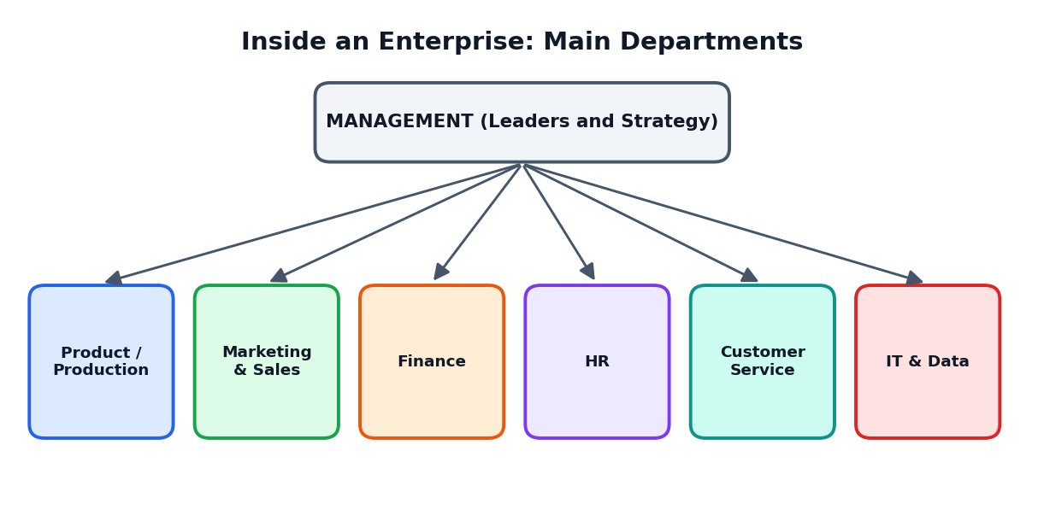
Figure 3.1: Typical departments in an enterprise
Department | What it does
Management | Sets goals, makes plans and leads the people
Product or Production | Designs and makes the product or prepares the service
Marketing and Sales | Tells people about the product and sells it
Finance | Manages money: income, costs, salaries, accounts and taxes
Human Resources (HR) | Hires, trains and supports employees
Customer Service | Helps customers with questions and problems
IT and Data | Takes care of computers, software, networks and data

3.4 The Value Chain
A value chain is the series of activities through which an enterprise creates a product or service and delivers it to the customer. At every step something is added that makes the product more valuable.
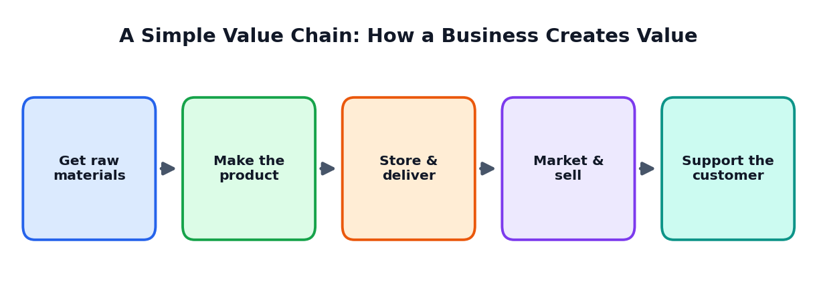
Figure 3.2: A simple value chain
EXAMPLE: A BAKERY
The bakery buys flour and sugar (raw materials), bakes bread (making), keeps it fresh and delivers it to shops (store and deliver), advertises on social media (market and sell) and takes feedback or complaints (support). AI could help at each step, for example by predicting how many loaves to bake each day.

3.5 Goals of an Enterprise
- Earn profit (for businesses) so that they can pay salaries and keep growing.
- Serve customers well with good quality and fair prices.
- Provide jobs and fair working conditions.
- Follow the law and take care of society and the environment.

3.6 Why Must Enterprises Keep Innovating?
- Customers change. Their needs and tastes keep shifting.
- Competition grows. Other enterprises keep improving.
- Technology advances. New tools make old methods slow.
- Costs rise. Better methods save time, materials and money.
- Rules and expectations change, such as environmental standards.
ACTIVITY 3.1: MAP AN ENTERPRISE
Choose a local enterprise you know (a shop, hospital, bus service, bank branch). Draw a simple value chain for it with five steps and write one problem at each step that innovation could solve.

3.7 Chapter Summary
- An enterprise is an organised group working for a purpose.
- Enterprises can be small, large, public, non-profit, cooperative or startups.
- Departments such as marketing, finance and HR work together.
- The value chain shows how value is added from raw material to customer support.
- Enterprises innovate to meet changing needs and stay competitive.
CHAPTER 4

AI in the Enterprise: Overview
A map of where AI helps inside organisations
CHAPTER GOALS
- See AI use cases across enterprise departments.
- Understand different kinds of AI tasks.
- Learn the levels of AI maturity.
- Know why people and AI work best together.

4.1 AI Use Cases: The Big Picture
A use case is a specific way in which a tool is used to solve a problem. Enterprises find many use cases for AI. The picture below shows common examples across different departments.
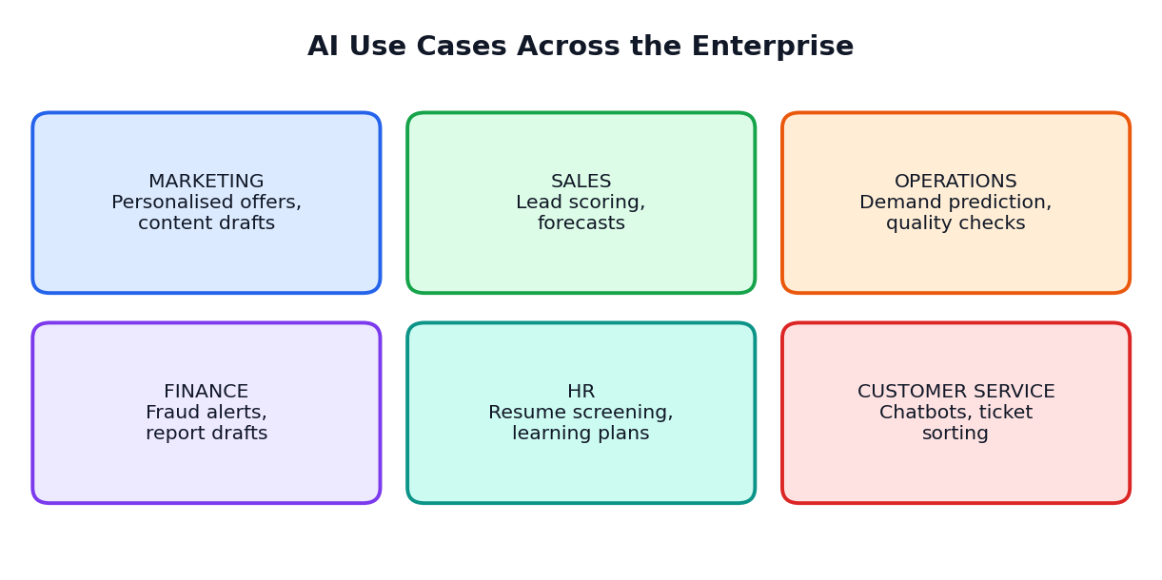
Figure 4.1: Typical AI use cases by department

4.2 What Kinds of Work Can AI Do?
Kind of AI task | Meaning | Enterprise example
Prediction | Guess what will happen | Forecast how many products will sell next week
Classification | Sort things into groups | Sort customer emails into complaints, questions, orders
Recognition | Identify things in images or sound | Find cracks in products on a conveyor belt
Recommendation | Suggest what a person may like | Suggest products to online shoppers
Language tasks | Understand and write text | Summarise a long contract or draft a reply
Generation | Create new content | Design poster options or write sample code
Optimisation | Find the best choice among many | Choose the cheapest, fastest delivery route

4.3 Levels of AI Maturity in an Enterprise
Not all enterprises use AI in the same way. Many climb a staircase from simple use to advanced use.
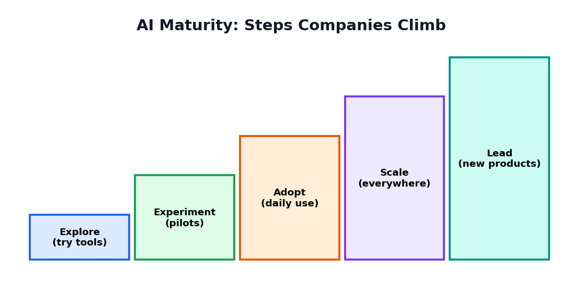
Figure 4.2: The AI maturity staircase
Level | What it looks like
Explore | People try free AI tools on their own to learn what is possible
Experiment | Teams run small pilot projects for specific problems
Adopt | AI becomes part of daily routines in some departments
Scale | AI is used across the whole enterprise with training and rules
Lead | AI helps create new products and new business models

TIP
A small enterprise does not need to reach the top step. It should choose the level that fits its needs, skills and budget.

4.4 Two Ways AI Reaches Employees
- Ready-made tools: The enterprise subscribes to tools for writing, design, translation or customer service.
- Custom solutions: The enterprise builds or orders special AI systems trained on its own data for its specific needs.
Ready-made tools are quick and cheap to start. Custom solutions can fit exactly but need more data, time, money and skills.

4.5 Humans Remain in the Loop
Inside enterprises, AI works best when a human checks important results, especially where money, safety, health or fairness is involved. This is called human-in-the-loop. For example, an AI may suggest which loan applications look risky, but a human officer reviews the final decision.
CAREFUL
Do not use AI to make final decisions about people (such as hiring, loans or punishment) without human review and a clear way for people to question the decision.

ACTIVITY 4.1: AI USE-CASE TABLE
Make a table with three columns: Department, Problem, How AI might help. Fill in at least six rows for a school, a hospital or a supermarket of your choice.

4.6 Chapter Summary
- AI use cases exist in almost every department of an enterprise.
- Main AI tasks: prediction, classification, recognition, recommendation, language, generation and optimisation.
- Enterprises move through stages: explore, experiment, adopt, scale and lead.
- Humans stay in the loop for important decisions.
CHAPTER 5

AI in Marketing, Sales and Customer Service
How AI helps enterprises understand, reach and support customers
CHAPTER GOALS
- Understand marketing and sales in simple terms.
- See how AI personalises messages and predicts demand.
- Learn how chatbots and human agents work together.
- Know the risks of using customer data.

5.1 Marketing and Sales: A Quick Introduction
Marketing means telling people about a product or service and understanding what they need. Sales means helping people buy. Customer service means helping them after they have bought. These three functions touch the customer directly, so even small improvements can make a big difference.

5.2 AI in Marketing
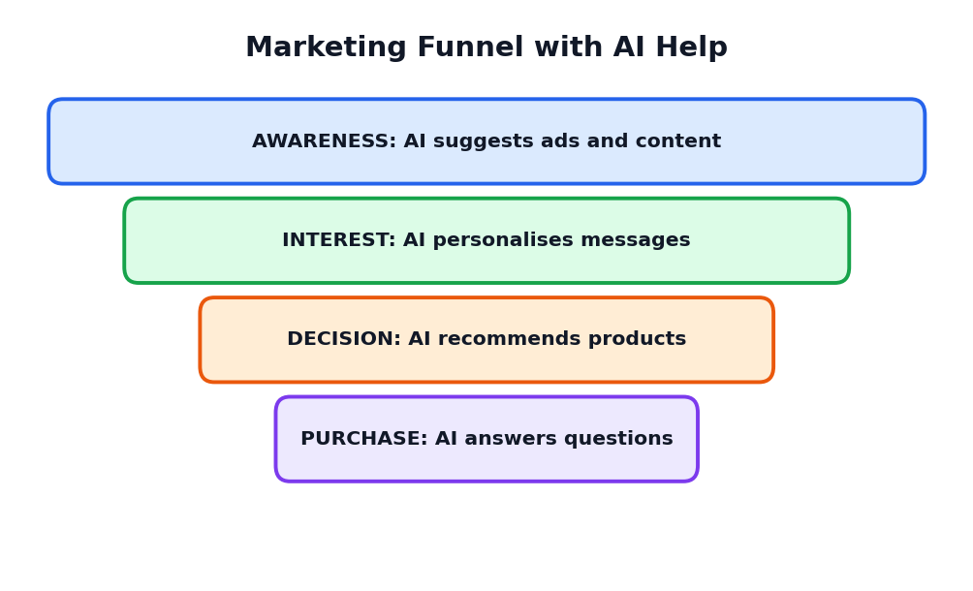
Figure 5.1: How AI can help at each stage of the marketing funnel

Personalised messages
AI can study what each customer likes and send a suitable message. Someone who often buys books may receive book offers, while someone who buys sports items may receive offers on sports shoes. This is called personalisation.

Content creation
Generative AI can create first drafts of advertisements, social media posts, product descriptions and posters. A human marketer then edits them to match the brand's voice and to remove mistakes.

Understanding customer opinions
AI can read thousands of reviews and comments and summarise them: What do people like? What do they complain about? This is called sentiment analysis.
IMAGINARY EXAMPLE: SUNRISE SWEETS
Sunrise Sweets collects 2,000 customer comments in a month. An AI tool groups them and shows that many customers like the taste but complain about packaging that leaks. The company improves the packaging and sales rise.

5.3 AI in Sales
- Lead scoring: AI ranks possible customers by how likely they are to buy, so that sales staff can focus on the best chances.
- Sales forecasting: AI predicts next month's sales using past data, seasons and festivals.
- Price suggestions: AI can suggest prices that attract buyers while keeping profit.
- Meeting notes: AI can write summaries and follow-up emails for sales calls.

5.4 AI in Customer Service
Customers want quick, clear answers. Chatbots and virtual assistants can answer common questions at any hour, such as 'Where is my order?' or 'What are your opening hours?'. When the problem is complex or the customer is upset, the chatbot passes the conversation to a human.
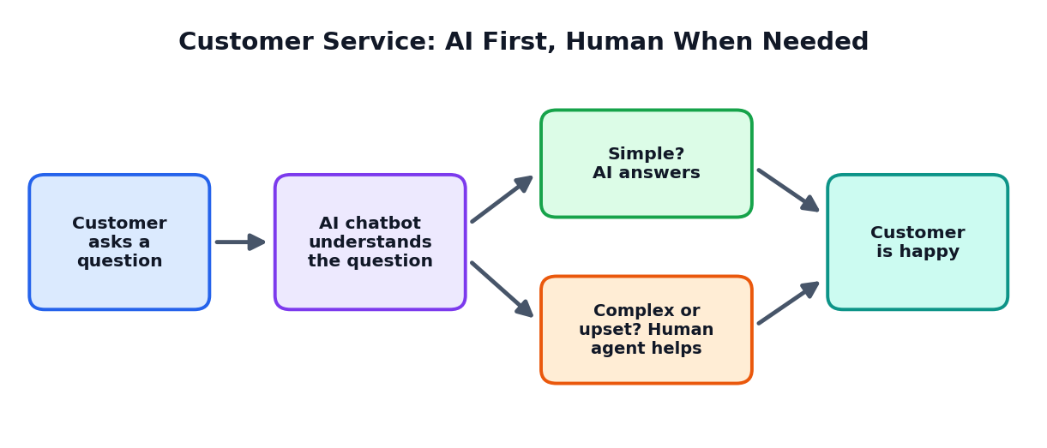
Figure 5.2: AI answers simple questions; humans handle complex ones
Task | Better with AI | Better with a human
Order status and opening hours | Quick and always available | Not needed
Sorting emails by topic | Fast and consistent | Only to check unusual cases
A customer who has a serious problem | Can collect basic details | Shows care and finds a fair solution
Special requests and exceptions | May not understand the situation | Can judge and decide

5.5 Benefits of AI in Customer-Facing Work
- Faster replies and shorter waiting time.
- Service available throughout the day and night.
- Consistent answers to common questions.
- More time for staff to handle complicated or sensitive cases.

5.6 Risks and Responsibilities
- Privacy: customer data must be collected with permission and protected.
- Honesty: customers should know when they are talking to AI.
- Wrong or fake information: chatbots can make mistakes, so answers must be tested.
- Annoying over-personalisation: too much targeting can feel like spying.
- Fairness: offers and prices should not treat groups of people unfairly.
TIP
Always give customers an easy way to reach a real person.

ACTIVITY 5.1: DESIGN A HELPER
Imagine you run a small online store. Write ten questions customers might ask a chatbot and mark which can be answered by AI alone and which need a human.

5.7 Chapter Summary
- AI helps marketing with personalisation, content drafts and understanding customer opinions.
- AI supports sales with lead scoring, forecasts and price suggestions.
- Chatbots handle simple questions; humans handle complex and emotional cases.
- Privacy, honesty and fairness are essential when using customer data.
CHAPTER 6

AI in Operations and Supply Chain
How AI helps enterprises make, store and deliver things better
CHAPTER GOALS
- Understand what operations and supply chain mean.
- Explain demand prediction and stock planning.
- Describe quality inspection and predictive maintenance.
- See how route planning saves time and fuel.

6.1 What Are Operations?
Operations is the part of an enterprise that actually makes the product or delivers the service: running the factory, the kitchen, the hospital ward or the delivery fleet. The supply chain is the network that brings materials in and sends finished products out to customers.

6.2 AI in the Supply Chain
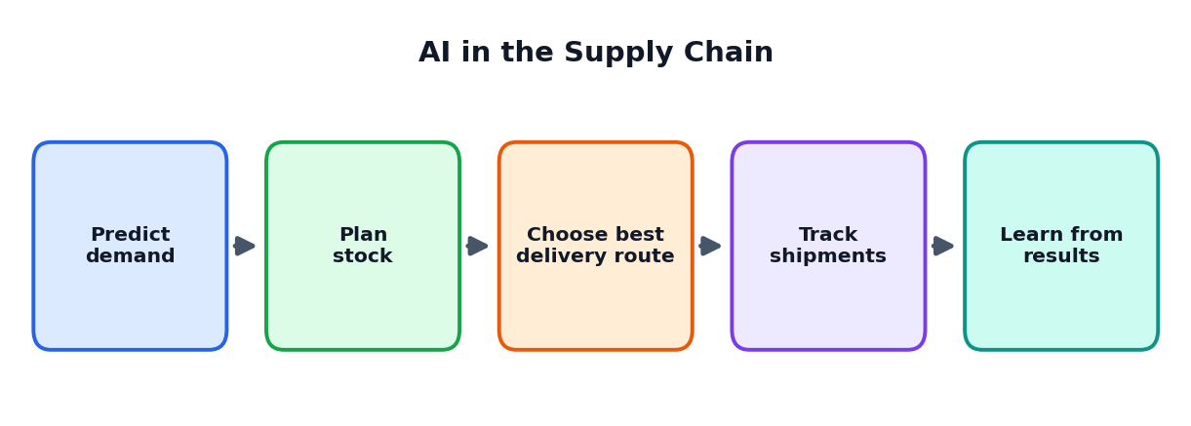
Figure 6.1: AI helps at every step of the supply chain

Predicting demand
If a company makes too many items, they remain unsold and money is wasted. If it makes too few, customers go away. AI studies past sales, seasons, festivals, prices and even weather to predict how much will be needed.

Planning stock
AI can suggest how much to keep in each warehouse or shop. This reduces waste, especially for items that spoil, like fruits and milk.

Choosing delivery routes
Delivery vehicles lose time in traffic. AI route planners compare many possible routes and choose the faster or cheaper one, saving fuel and giving earlier delivery.

Tracking shipments
Sensors and software track where goods are. If a delay happens, AI can warn customers and suggest solutions.
IMAGINARY EXAMPLE: FRESH BASKET VEGETABLES
Fresh Basket sells vegetables in many neighbourhoods. Earlier, 15 percent of vegetables spoiled unsold. After using a prediction tool, the company orders closer to real demand and spoilage falls sharply. (The numbers here are imaginary, only to explain the idea.)

6.3 AI in Manufacturing

Quality inspection
Cameras connected to AI can check each product on a production line for scratches, cracks or wrong colours. They never get tired and can inspect very fast. Humans check unclear cases and fix the cause of the problem.

Predictive maintenance
Machines break down, and sudden breakdowns can stop work and cause loss. Sensors measure vibration, heat and sound. AI learns what normal looks like and warns the engineer when something looks unusual, so that repair can happen at a convenient time.
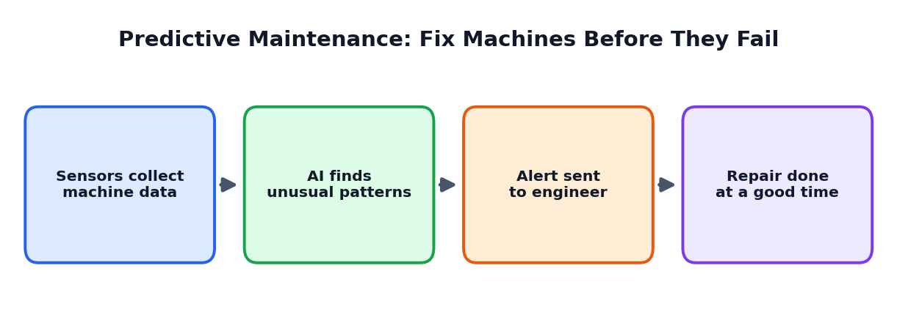
Figure 6.2: Predictive maintenance
Approach | How it works | Problem
Fix after breaking | Wait until the machine stops | Sudden stoppage and high cost
Fix on a fixed schedule | Repair every few months regardless | May waste parts and time
Predictive maintenance | Repair when data shows a problem is coming | Needs sensors and data, but saves cost

Safety monitoring
AI-enabled cameras can notice when a worker is not wearing a helmet or when someone enters a dangerous area, and send a warning. This must be used carefully and fairly, with respect for workers' privacy.

6.4 Robots and Automation
Automation means machines or software doing tasks with little human effort. Robots are machines that can move and perform physical tasks, such as lifting boxes in a warehouse. AI makes robots better at seeing and deciding. However, people are still needed to design, supervise and repair them.

6.5 Saving Resources and Helping the Environment
- Better predictions reduce waste of food and materials.
- Better routes reduce fuel use.
- Energy-use analysis helps factories lower electricity consumption.
- Early repair prevents leaks and breakdowns that harm the environment.
ACTIVITY 6.1: FIND THE WASTE
Visit a shop, canteen or workshop (or imagine one). List three places where time, food, money or energy is wasted. For each, write what data could be collected and how AI could help reduce the waste.

6.6 Chapter Summary
- Operations make or deliver the product; the supply chain moves materials and goods.
- AI predicts demand, plans stock, finds good routes and tracks shipments.
- Camera-based AI inspects quality; sensors with AI predict machine failure.
- Automation needs human supervision, safety care and fairness to workers.
CHAPTER 7

AI in HR, Finance and Administration
How AI supports the people and money side of an enterprise
CHAPTER GOALS
- Understand the work of HR, finance and administration.
- See how AI helps hiring, learning, accounts and fraud checking.
- Understand why human decisions and fairness are vital.

7.1 AI in Human Resources (HR)
The HR department takes care of people in the enterprise: hiring, training, salaries, welfare and growth. HR deals with real lives, so the use of AI here needs special care.
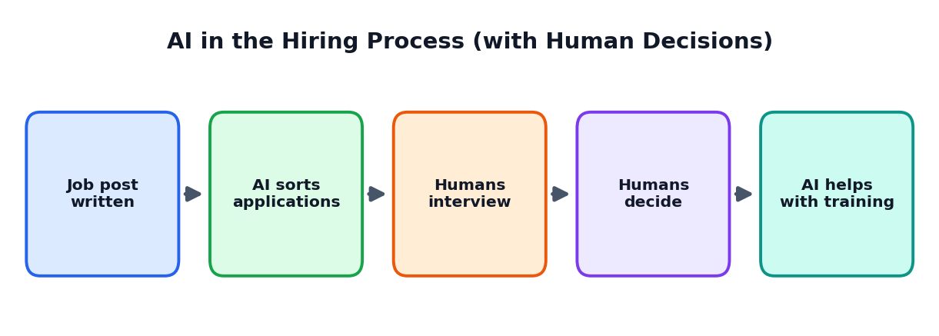
Figure 7.1: AI can assist the hiring process, but humans decide

Writing job descriptions
Generative AI can draft clear job descriptions and interview questions, which HR staff then check and adapt.

Sorting applications
When hundreds of people apply, AI can group applications by skills, saving time. But the system must not unfairly reject people because of gender, community, age, name or place. Humans must review the rules and the results.

Training and learning
AI can suggest personal learning plans, create quizzes and answer employees' questions about company rules. New employees can ask a helper tool where to find a form or how to apply for leave.

Employee support
AI can summarise feedback surveys to show what employees are worried about, helping the enterprise to improve the workplace.
CAREFUL
Hiring is a decision that affects a person's life. AI should assist, not decide alone. Candidates should be treated fairly, and their data must be kept private.

7.2 AI in Finance
The finance department manages money: income, costs, salaries, taxes and records. AI helps by finding patterns and handling repetitive work.
Finance task | How AI helps | Human role
Fraud detection | Spots unusual payments or card use and raises alerts | Investigates the alert and decides action
Invoice processing | Reads bills and enters data automatically | Checks unclear or high-value cases
Budget forecasting | Predicts future income and costs from past data | Chooses plans and sets priorities
Report writing | Drafts summaries of financial results | Verifies numbers and adds meaning
Loan checking in banks | Estimates the risk of non-payment | Final decision; fairness check

IMAGINARY EXAMPLE: FRAUD ALERT
A customer usually spends small amounts in Chennai. Suddenly, a very large payment appears from another country within minutes. The bank's AI marks it unusual and sends a message asking the customer to confirm. The customer says it was not them, and the bank stops the payment. AI spotted the pattern; humans solved the case.

7.3 AI in Administration and Office Work
- Meeting notes: AI converts speech into text and summarises key decisions.
- Email help: AI drafts replies and sorts messages by importance.
- Document handling: AI finds information in large collections of files.
- Translation: AI helps translate notices and letters into different languages.
- Scheduling: AI suggests meeting times that suit everyone.

7.4 AI in Law and Compliance (Simple View)
Enterprises must follow rules and laws. AI can help by scanning long documents to find important clauses or by reminding staff about deadlines. However, AI must never replace a qualified lawyer's advice for important legal decisions.

7.5 Fairness and Privacy in People-Related Work
- Check that data used for training does not contain unfair patterns.
- Collect only the information that is really needed.
- Explain to employees how AI is used and give a way to question decisions.
- Protect salary, health and personal details with strong security.
ACTIVITY 7.1: FAIR OR UNFAIR?
Read these situations and decide if the use of AI is fair, risky or unfair. Explain why. (a) AI writes first drafts of job advertisements. (b) AI automatically rejects every applicant above a certain age. (c) AI summarises employee feedback for managers. (d) AI reads employees' private messages.

7.6 Chapter Summary
- In HR, AI helps with job descriptions, application sorting, training and surveys, but people make the final decisions.
- In finance, AI helps detect fraud, process bills, forecast and draft reports.
- In administration, AI saves time in notes, emails, translation and scheduling.
- Fairness, privacy and human review are essential in people-related decisions.
CHAPTER 8

AI Across Industry Sectors
Snapshots of AI use in healthcare, banking, farming, education, retail and transport
CHAPTER GOALS
- Learn how AI is used in several important sectors.
- Understand benefits and cautions for each sector.
- Identify local opportunities for innovation.

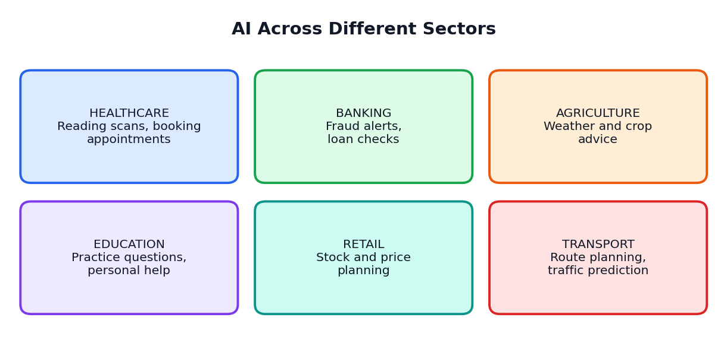
Figure 8.1: AI in different sectors

8.1 Healthcare
Hospitals and clinics deal with large amounts of information such as scans, test reports and patient records. AI can help doctors by pointing out areas to look at on a scan, summarising patient history, booking appointments and reminding patients to take medicines.
- Benefit: faster support for doctors and easier access to information.
- Caution: health data is very private; wrong advice can harm. Doctors, not AI, must make the final medical decisions.

8.2 Banking and Insurance
Banks use AI to detect fraud, answer customer questions, estimate loan risk and suggest suitable services. Insurance companies use it to check claims faster.
- Benefit: safer transactions and quicker service.
- Caution: unfair loan decisions and misuse of financial data must be avoided.

8.3 Agriculture
Farmers face uncertain weather, pests and changing prices. AI tools can analyse weather and soil data to give advice on sowing and irrigation, identify plant diseases from photos, and predict market prices. Voice assistants in local languages can help farmers who find reading difficult.
- Benefit: better use of water and fertiliser, improved harvest decisions.
- Caution: advice must fit local conditions; farmers need training and affordable access.

8.4 Education
Schools and colleges use AI to create practice questions, explain difficult topics in different ways, translate learning materials and support students who need extra help. Teachers can save time on routine tasks and spend more time with students.
- Benefit: personalised learning and saved teacher time.
- Caution: students must still think and write on their own; AI answers must be checked.

8.5 Retail and E-commerce
Shops use AI to predict which products will sell, decide how much stock to keep, suggest products to online shoppers and answer questions. Even small shops can use simple tools to track what sells best.

8.6 Transport and Logistics
AI helps plan bus and delivery routes, predict traffic, reduce waiting times and improve safety by detecting driver tiredness. Public transport can use data to match the number of buses to the number of passengers.

8.7 Comparing the Sectors
Sector | Main data used | Typical AI help | Main caution
Healthcare | Scans, records, tests | Support for doctors, reminders | Privacy and accuracy
Banking | Transactions, accounts | Fraud alerts, chat support | Fairness and security
Agriculture | Weather, soil, images | Crop and irrigation advice | Local suitability
Education | Lessons, student work | Practice, explanation | Honesty and real learning
Retail | Sales, stock, prices | Demand prediction | Over-targeting customers
Transport | Maps, traffic, timings | Route and schedule planning | Safety and reliability

8.8 Finding Local Opportunities
Many valuable innovations come from understanding local problems. A town known for textiles may need better quality checking. A coastal village may need weather alerts for fishermen. A school in a rural area may need translated learning tools. Students who understand their own region can spot opportunities that big companies overlook.
ACTIVITY 8.1: LOCAL PROBLEM, AI IDEA
Choose your town or village. List three important local activities (such as farming, textiles, small trade, transport). For each, write one problem and a possible AI-supported solution. Share your list with the class.

8.9 Chapter Summary
- AI is used across healthcare, banking, agriculture, education, retail and transport.
- Each sector has its own data, benefits and cautions.
- Local problems can inspire useful AI innovations.
CHAPTER 9

Data: The Fuel of Enterprise AI
Why data matters and how good data is prepared
CHAPTER GOALS
- Understand what data is and its types.
- Learn the five marks of good data.
- Follow the journey from raw data to decisions.
- Know how enterprises protect data.

9.1 What Is Data?
Data means facts and figures collected about something: numbers, words, pictures, sounds, locations and records. A shop's sales list, a hospital's patient records, photographs of crops and customer reviews are all data.
AI learns from data in the same way that you learn from examples and practice. Good, plentiful and fair data helps AI to learn well. Poor data confuses it. That is why people say, 'Data is the fuel of AI'.

9.2 Types of Data
Type | Meaning | Examples
Structured data | Organised in rows and columns | Sales tables, attendance registers, bank statements
Unstructured data | Not in a fixed table form | Emails, photos, videos, voice recordings, reviews
Time-based data | Collected again and again over time | Daily temperature, hourly electricity use
Location data | Where something is | Delivery vehicle positions, shop addresses

9.3 Where Do Enterprises Get Data?
- Inside the enterprise: sales records, customer lists, machine sensors, employee records.
- From customers: forms, reviews, app use, surveys (with permission).
- From outside: public information, weather reports, government statistics.
- Bought or shared data: from partners, following rules and agreements.

9.4 The Five Marks of Good Data
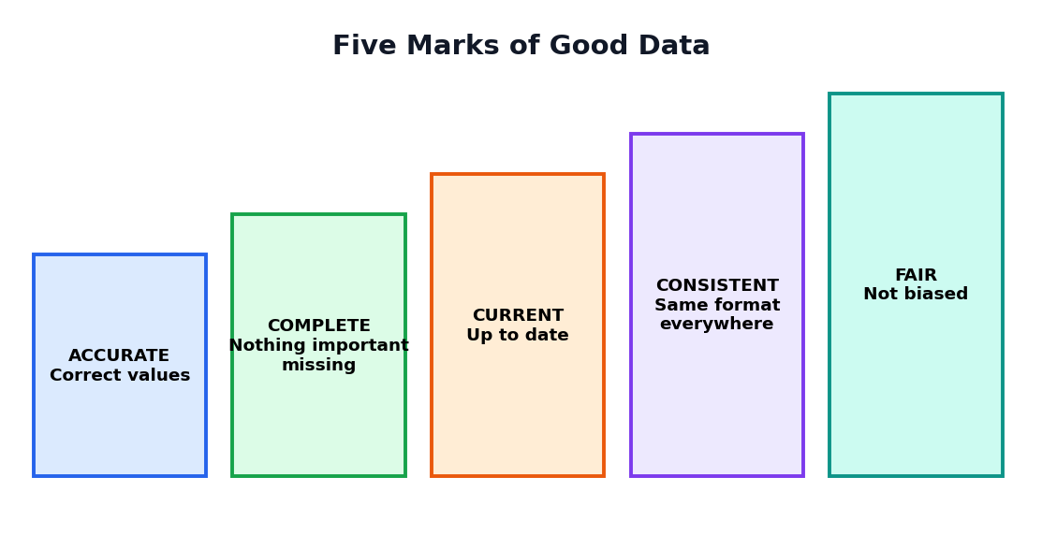
Figure 9.1: Five marks of good data
Mark | Meaning | Problem if missing
Accurate | Values are correct | Wrong decisions, e.g. wrong price entered
Complete | Nothing important is missing | Partial picture, e.g. missing months of sales
Current | Up to date | Old data leads to old answers
Consistent | Same format everywhere | Confusion, e.g. dates written in different styles
Fair | Represents all groups properly | Bias, unfair results for some people

KEY IDEA
Garbage in, garbage out. If the data given to AI is poor, the output will also be poor.

9.5 From Raw Data to Decisions
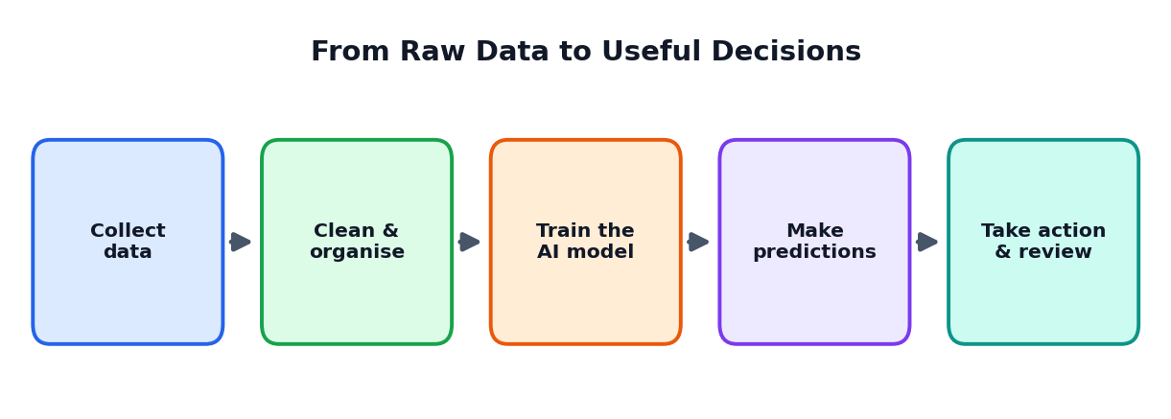
Figure 9.2: The data journey
- Collect: gather data from the right sources, with permission.
- Clean and organise: fix mistakes, remove duplicates, fill gaps, use one format.
- Train the model: let the AI learn patterns from the prepared data.
- Predict: use the trained AI on new situations.
- Act and review: people use the results and check how well they worked.
IMAGINARY EXAMPLE: CLEANING DATA
A school collects feedback with names of classes typed as '12A', '12-A', 'Twelve A' and '12 a'. For a computer these look like four different classes. The data team changes them all to '12A' so that the count is correct.

9.6 Data Security and Privacy
Data may contain private information. Enterprises must protect it from loss, theft and misuse.
- Collect only what is needed. Do not ask for extra personal details.
- Get permission and explain how data will be used.
- Protect with passwords, encryption and limited access. Only authorised people should see sensitive data.
- Remove names when possible (anonymise) before analysis.
- Delete data that is no longer needed.
- Follow laws about data protection in the country.
CAREFUL
Never paste private customer or employee data into public AI tools. Use only approved tools and follow your organisation's rules.

9.7 Data and Fairness
If a company has data mostly from one city or one group of people, the AI may work badly for others. Enterprises should check whether their data represents all the people they serve and should test results for different groups.
ACTIVITY 9.1: DATA DETECTIVE
Collect simple data from your class, such as the mode of travel to school or favourite subject of ten classmates (without names). Enter it in a table. Check: is it accurate, complete, current, consistent and fair? What problems did you find? How would you fix them?

9.8 Chapter Summary
- Data is facts, numbers, text, images and sounds; AI learns from it.
- Good data is accurate, complete, current, consistent and fair.
- The data journey: collect, clean, train, predict, act and review.
- Protecting privacy and security of data is a serious duty.
CHAPTER 10

Building an AI Solution
The life cycle of an enterprise AI project, explained in simple steps
CHAPTER GOALS
- Learn the six stages of an AI project.
- Understand who works in an AI team.
- See how to test an AI solution before use.
- Know why monitoring never ends.

10.1 The AI Project Life Cycle
Building an AI solution is like building a bridge: you cannot start by pouring concrete. You must understand the need, prepare the materials, build carefully, test, open it for use and keep checking it. The six stages are shown below.
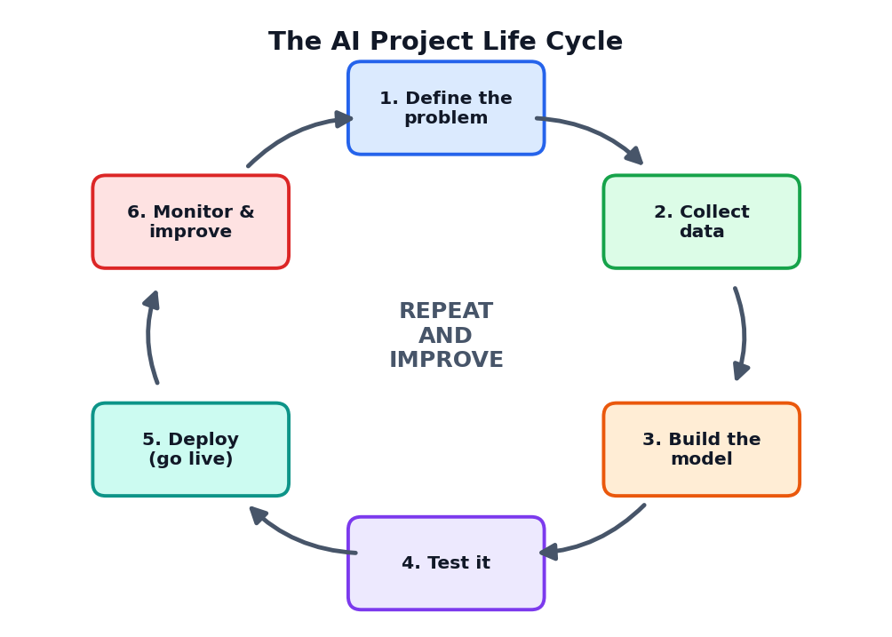
Figure 10.1: The six stages of an AI project

10.2 Stage 1: Define the Problem
Start with a clear problem, not with a tool. A good problem statement says who has the problem, what the problem is and how success will be measured. For example: 'Customers wait 10 minutes for answers on our helpline. We want 70 percent of simple questions answered within one minute.'
TIP
Ask: do we really need AI for this? Sometimes a simple change in rules or a better form is enough.

10.3 Stage 2: Collect and Prepare Data
Decide what data is needed, collect it with permission, clean it and keep it safe. This stage often takes the most time. Without good data, even the best AI tool will not help.

10.4 Stage 3: Build the Model
A model is the trained AI system. Teams may use a ready-made model, adjust an existing one with their own data, or train a new one. Specialists such as data scientists and engineers do this work, together with experts from the department that will use the solution.

10.5 Stage 4: Test It
Before using the solution in real life, test it carefully with data it has not seen before. Testing questions include:
- Is it accurate enough for this task?
- Does it work well for all groups of people and situations?
- What kinds of mistakes does it make? How serious are they?
- Is it safe and secure? Can someone misuse it?
- Do real users find it easy to use?

10.6 Stage 5: Deploy (Go Live)
Deployment means putting the solution into real use. Wise teams begin with a small group of users, called a pilot, and expand step by step. They also train employees and explain clearly what the AI can and cannot do.

10.7 Stage 6: Monitor and Improve
The world changes, so an AI model that worked well last year may become less accurate. Teams must keep watching its performance, collect feedback, fix problems and update the system. Then the cycle starts again.

10.8 Who Works on an AI Project?
Role | What the person does
Business owner / department head | Explains the problem, decides if the result is useful
Data engineer | Collects, cleans and organises the data
Data scientist / AI specialist | Builds and tests the model
Software developer | Connects the AI to apps and systems people use
User or customer representative | Tests and gives honest feedback
Ethics, legal and security experts | Check privacy, fairness, safety and rules
Project manager | Plans time, cost and teamwork

10.9 Buy, Build or Borrow?
Option | Meaning | Good when
Buy a ready tool | Subscribe to existing software | The need is common and speed matters
Customise | Adapt an existing model with own data | Some special needs exist
Build from scratch | Create a new model | Need is unique and the team has strong skills

ACTIVITY 10.1: PLAN AN AI PROJECT
Choose a problem in your school (for example: long queues at the canteen). Write a one-line problem statement and answer for each of the six stages: what you will do, who will help, and how you will know it works.

10.10 Chapter Summary
- Six stages: define the problem, collect data, build the model, test, deploy, monitor and improve.
- A clear problem statement and good data are the foundation.
- Testing must include fairness, safety and real user feedback.
- AI projects are teamwork. Monitoring never stops.
CHAPTER 11

Innovation Methods
Design thinking, idea funnels, prototypes and pilots
CHAPTER GOALS
- Learn the five stages of design thinking.
- Use AI for brainstorming and idea selection.
- Understand prototypes, MVPs and pilots.
- Apply the build-measure-learn loop.

11.1 Design Thinking
Design thinking is a people-first method for solving problems. Instead of starting with technology, you start by understanding the people who face the problem.
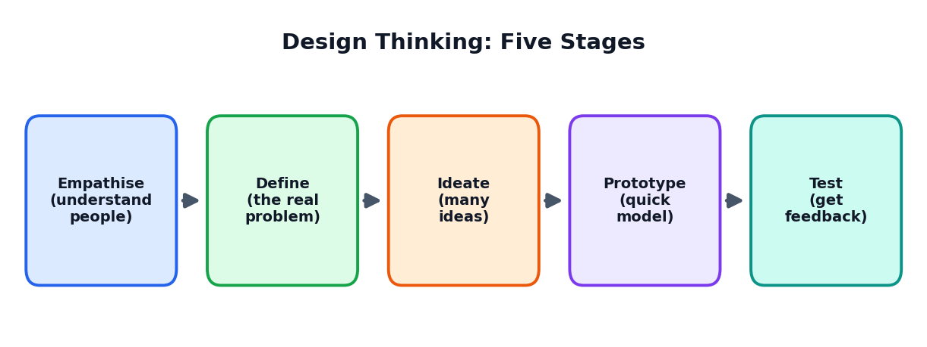
Figure 11.1: The five stages of design thinking
Stage | What you do | Example: improving the school canteen
Empathise | Talk to and observe people | Watch students waiting; ask why they leave without eating
Define | State the real problem clearly | Students have only 15 minutes and queues take 12
Ideate | Create many ideas | Pre-order by phone, more counters, token system
Prototype | Make a quick, simple version | Paper token system tested for one day
Test | Try with real users and improve | Students say tokens help but menu is unclear; improve menu board

11.2 Brainstorming with AI
Generative AI is useful in the ideate stage. You can ask for many ideas and then choose with your human judgement.
SAMPLE PROMPT FOR IDEAS
"Act as an innovation coach. Our school canteen has long queues during the 15-minute break. Suggest 10 low-cost ideas to reduce waiting time. For each, give one benefit and one possible difficulty. Use a table."

TIP
Do not accept the first list. Ask for more unusual ideas, ideas from other fields, or ideas for a small budget. Combine the best parts of different ideas.

11.3 The Innovation Funnel
Innovation starts with many ideas, but only a few can be developed. Selection happens step by step, like a funnel.
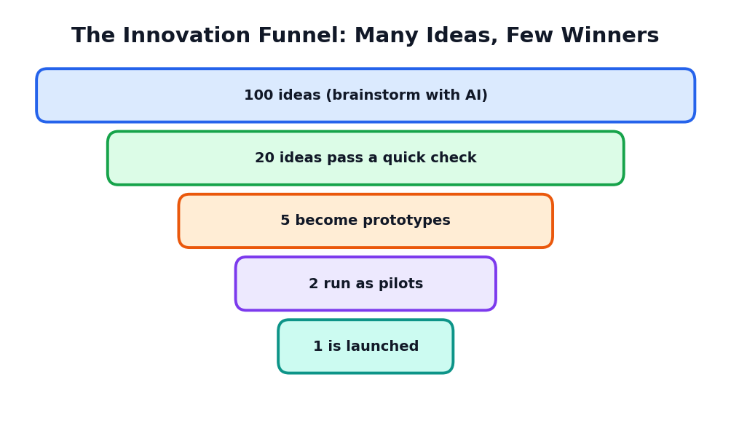
Figure 11.2: Many ideas enter; few are launched

How to select ideas
Compare ideas using simple questions. Give each idea a score from 1 to 5.
Idea | Helpful for users? | Easy to do? | Low cost? | Safe and fair? | Total
Token system | 5 | 4 | 5 | 5 | 19
Pre-order app | 4 | 2 | 3 | 4 | 13
More counters | 3 | 3 | 2 | 5 | 13

11.4 Prototype, MVP and Pilot
Term | Meaning | Example
Prototype | A quick, rough model to test an idea | A paper sketch of an app screen
MVP (Minimum Viable Product) | The simplest working version that real users can try | An app with only the ordering button
Pilot | A small real-world trial before full launch | Running the token system in one class block for a week

A prototype is a way to learn cheaply. It is much better to discover a problem with a paper model than after spending lots of money.

11.5 Build - Measure - Learn
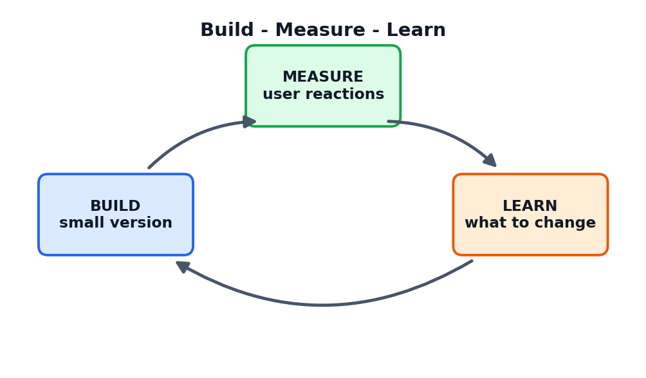
Figure 11.3: The learning loop of innovators
Build a small version, measure how people use it, and learn what to change. Then build again. Each loop makes the idea stronger. This method keeps risk low and helps teams stay close to what users really need.

11.6 Measuring Success: Simple KPIs
A KPI (Key Performance Indicator) is a number that shows whether you are succeeding. Choose a few clear KPIs before starting a pilot.
Project | Possible KPI
Canteen token system | Average waiting time in minutes; number of students served
Customer chatbot | Percentage of questions solved without a human; customer satisfaction score
Machine monitoring | Number of sudden breakdowns per month
Learning helper tool | Quiz scores before and after; student opinions

ACTIVITY 11.1: MINI DESIGN THINKING
Work in a team of four. Pick a real problem in your school. Go through empathise, define, ideate, prototype and test in a week. Record each stage with a short note or a photo, and present your results.

11.7 Chapter Summary
- Design thinking has five stages: empathise, define, ideate, prototype and test.
- AI is excellent for generating many ideas; humans select and refine them.
- Prototypes, MVPs and pilots help to learn cheaply and reduce risk.
- Build-measure-learn is a continuous loop; KPIs show progress.
CHAPTER 12

Strategy, ROI and Change Management
How enterprises decide, measure value and help people adopt AI
CHAPTER GOALS
- Understand AI strategy in simple terms.
- Compare costs and benefits and understand ROI.
- Choose which AI projects to do first.
- Learn how to help people accept and use AI.

12.1 What Is an AI Strategy?
A strategy is a long-term plan to reach a goal. An enterprise's AI strategy answers four questions: Why should we use AI (what goals)? Where should we use it first? How will we build skills, data and tools? What rules will we follow to stay safe and fair?
KEY IDEA
AI should serve the goals of the enterprise. We begin with the goal, not with the tool.

12.2 Costs of an AI Project
Cost type | Examples
Tools and technology | Software subscriptions, computers, cloud services, sensors
Data | Collecting, cleaning, storing and protecting data
People | Specialists, trainers, project time of staff
Training | Teaching employees to use AI properly
Maintenance | Monitoring, updates, fixing problems
Risk and rules | Security, legal checks, insurance

12.3 Benefits of an AI Project
- Saves time: tasks finish faster.
- Saves money: less waste, fewer errors, lower repair costs.
- Earns more: better service, new customers, new products.
- Improves quality and safety: fewer faults and accidents.
- Improves satisfaction: customers and employees are happier.

12.4 Return on Investment (ROI)
ROI compares what you gain with what you spend. A simple formula is:
ROI FORMULA
ROI (%) = (Benefit - Cost) / Cost x 100

WORKED EXAMPLE (IMAGINARY NUMBERS)
A bakery spends Rs. 50,000 on a tool that predicts daily demand. Over a year it saves Rs. 80,000 by reducing wasted bread and lost sales.
Net gain = 80,000 - 50,000 = Rs. 30,000.
ROI = 30,000 / 50,000 x 100 = 60 percent.

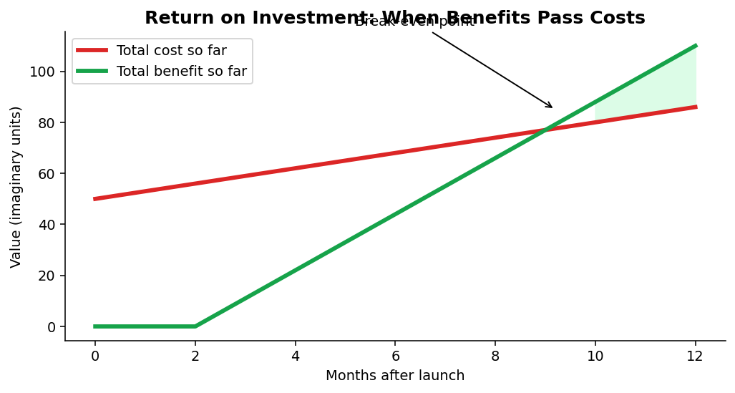
Figure 12.1: Early on, costs are higher; benefits grow and pass costs at the break-even point
Not every benefit can be counted in money. Safer working conditions, happier customers and better learning are valuable too. A good decision considers both measurable and non-measurable results.

12.5 Which Project First?
Enterprises have many ideas but limited time and money. A simple way to decide is to give each idea a score for value (how helpful) and ease (how simple), then start with high-value, easy projects.
Idea | Value (1-5) | Ease (1-5) | Decision
Chatbot for common questions | 4 | 4 | Start now
Predict machine failures | 5 | 2 | Plan carefully; start a pilot
AI to write all company news | 2 | 5 | Maybe later
Fully automatic hiring | 3 | 1 | Avoid; risky and unfair

12.6 Change Management: Helping People Adopt AI
Even the best technology fails if people do not accept it. Some employees may fear losing their jobs, others may not understand how to use the tool, and some may simply prefer the old way. Change management means helping people move to new ways of working smoothly.
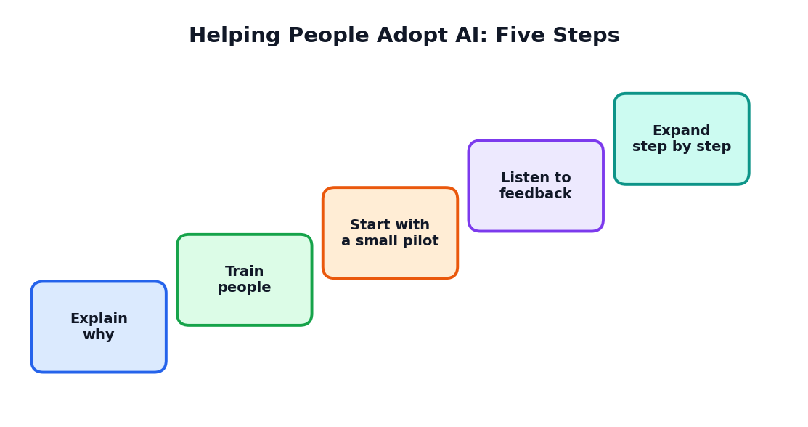
Figure 12.2: Five steps to help people adopt AI
Step | What to do
Explain why | Share the reasons and the benefits honestly; answer worries
Train people | Teach skills and safe use through practice, not only lectures
Start with a pilot | Try with a small, willing group first
Listen to feedback | Fix problems; show people that their voice matters
Expand step by step | Grow use gradually, celebrating success

12.7 Leadership and Culture
Leaders set the tone. When leaders encourage learning, accept honest mistakes and reward good ideas, employees feel safe to try new things. A culture of curiosity and responsibility is the best base for innovation.
ACTIVITY 12.1: ROI PRACTICE
A small tailoring shop spends Rs. 20,000 on a tool that helps manage orders. In one year it saves Rs. 5,000 of wasted cloth and earns Rs. 25,000 more due to quicker delivery. Calculate the net gain and the ROI. Then list two benefits that cannot be measured in money.

12.8 Chapter Summary
- AI strategy answers: why, where, how and what rules.
- Costs include tools, data, people, training, maintenance and risk; benefits include time, money, quality and satisfaction.
- ROI = (Benefit - Cost) / Cost x 100.
- Start with high-value, easy projects; avoid high-risk uses.
- Change management (explain, train, pilot, listen, expand) helps people adopt AI.
CHAPTER 13

Responsible AI and the Future of Work
Using AI in ways that are safe, fair and good for people
CHAPTER GOALS
- Learn five pillars of responsible AI in an enterprise.
- Understand the main risks and how to reduce them.
- Discuss how jobs and skills are changing.
- Prepare yourself for the future.

13.1 Why Responsibility Matters
Enterprises have power: they make decisions that affect customers, employees and society. When AI is used, mistakes can be repeated thousands of times quickly. So enterprises must use AI carefully and honestly.
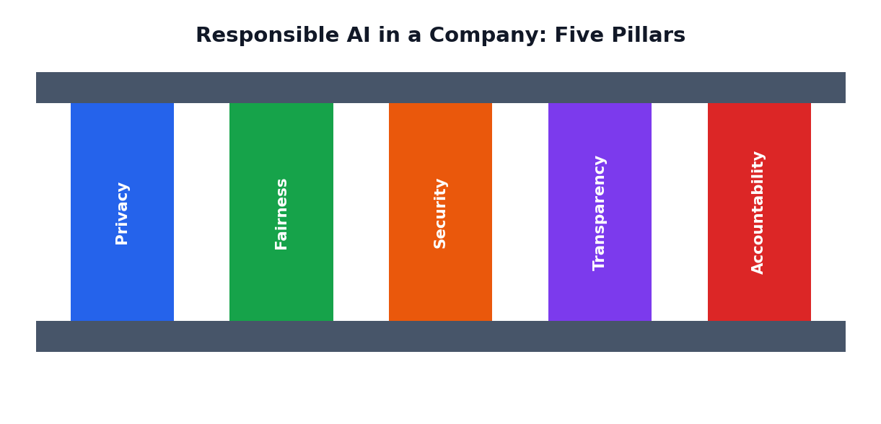
Figure 13.1: Five pillars of responsible AI in an enterprise

13.2 The Five Pillars
Pillar | Meaning | Example action
Privacy | Protect personal data | Collect only needed data; delete when not needed
Fairness | Treat people equally; avoid bias | Test the AI results for different groups
Security | Protect systems and data from attack | Strong passwords, access limits, regular checks
Transparency | Be open about where and how AI is used | Tell customers when they talk to a chatbot
Accountability | A person is responsible for outcomes | Name a manager who owns each AI system

13.3 Main Risks of Enterprise AI
Risk | What can happen | How to reduce it
Wrong output (hallucination) | Customers receive false information | Test; keep human review; show sources
Bias | Some groups are treated unfairly | Check data; test results across groups
Privacy leak | Private data becomes public | Use approved tools; limit access; anonymise
Misuse | People use AI to cheat or deceive | Rules, monitoring, training
Over-dependence | Staff stop thinking and checking | Keep humans in the loop; practise skills
Job fear | Employees worry about losing work | Honest talk; retraining; new roles

13.4 Rules and Laws
Countries are making laws and guidelines about data protection and the use of AI. Enterprises must follow them. Good enterprises also create their own AI policy: a short document that says which tools may be used, what data may be shared and what checks are needed.
TIP: A SIMPLE AI POLICY FOR A SMALL ENTERPRISE
- Use only approved AI tools.
- Never enter private customer or employee data into public tools.
- A human must review AI output before it is shared with customers.
- Keep a record of where AI was used for important work.
- Report mistakes quickly and learn from them.

13.5 How Are Jobs Changing?
Every big technology has changed jobs. Some tasks disappear, some jobs change and new jobs appear. With AI, repetitive tasks such as data entry, sorting and basic drafting are being done faster. At the same time, new roles are growing, such as data analyst, AI trainer, prompt designer, AI ethics officer and automation specialist.
Changing | Growing
Repetitive typing and data entry | Data analysis and decision support
Basic report drafting | Editing, checking and improving reports
Routine customer answers | Handling complex and caring customer cases
Manual inspection of simple faults | Maintaining and supervising smart systems

13.6 Skills for the Future
- Digital and AI literacy: knowing how to use tools wisely.
- Critical thinking: questioning and checking.
- Creativity and problem solving: finding new solutions.
- Communication and teamwork: working well with people.
- Adaptability: learning new things again and again.
- Ethics: deciding what is right when no rule exists.
CAREFUL
Be honest about the effects of AI. Replacing people without care harms families. Responsible enterprises plan retraining and fair transitions.

ACTIVITY 13.1: DEBATE
Hold a class debate on: 'AI will create more opportunities than it removes.' One group supports, the other opposes. Use facts and examples, listen to each other, and write a short conclusion at the end.

13.7 Chapter Summary
- Responsible AI rests on privacy, fairness, security, transparency and accountability.
- Risks include wrong output, bias, leaks, misuse, over-dependence and job fears.
- Enterprises should create simple AI policies.
- Jobs are changing: routine tasks shrink, and analysis, creativity, care and supervision grow.
CHAPTER 14

Startups and Entrepreneurship with AI
From a simple idea to a one-page plan
CHAPTER GOALS
- Understand what a startup and an entrepreneur are.
- Learn how AI lowers the barrier to starting.
- Create a one-page business plan.
- Judge an AI idea using a checklist.

14.1 What Is a Startup?
A startup is a new enterprise created to solve a problem in a new way, often with the aim of growing fast. The person who starts and runs it is an entrepreneur. Entrepreneurs take risks, build teams and keep learning.

14.2 How AI Helps New Entrepreneurs
- Lower cost: free or low-cost tools can write drafts, design logos and answer customers.
- Faster start: a small team can do work that once needed a large staff.
- Market understanding: AI can summarise customer opinions and competitor information.
- Learning support: AI can explain unfamiliar topics such as accounts or marketing.
- Prototype making: quick drafts of app screens, brochures or websites.
CAREFUL
AI makes starting easier, but it does not remove the need for hard work, honest dealing and real understanding of customers.

14.3 From Problem to Business Idea
- Find a real problem that people care about.
- Talk to at least ten possible customers.
- Think of a solution where AI gives a clear benefit.
- Check that you can get the data, tools and skills you need.
- Make a prototype and test it quickly.
- Decide how the idea will earn money or create social value.

14.4 The One-Page Plan
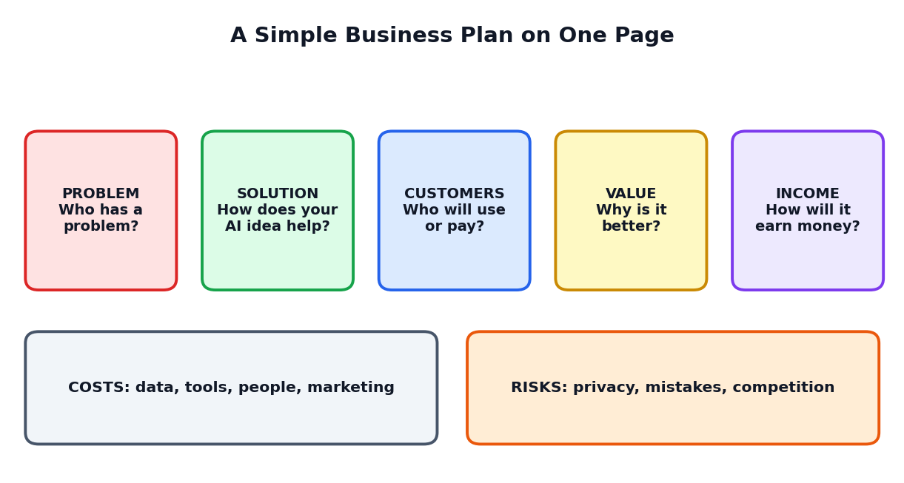
Figure 14.1: A simple one-page business plan
Part | Questions | Example: 'Farm Helper' voice assistant
Problem | Who has what difficulty? | Small farmers cannot easily get reliable crop advice
Solution | How does your idea help? | A voice assistant giving advice in local language
Customers | Who will use or pay? | Farmer groups, cooperatives, agri-shops
Value | Why is it better than current options? | Quick, local language, always available
Income | How will it earn money? | Monthly subscription by cooperatives
Costs | What must you spend on? | Data, development, field testing, support
Risks | What could go wrong? | Wrong advice; poor internet; privacy of farm data

14.5 The AI Idea Checklist
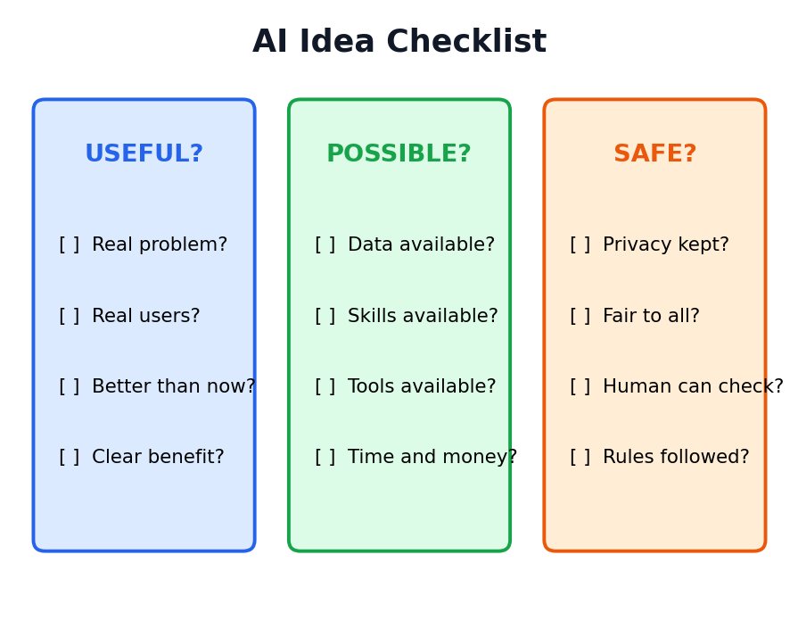
Figure 14.2: Is your AI idea useful, possible and safe?

14.6 Learning from Failure
Most startups face failure at some point. The wise entrepreneur treats failure as feedback. Ask: What did we learn? What will we change? Many successful companies changed their original idea after listening to customers.

14.7 Social Entrepreneurship
Not all enterprises aim mainly at profit. Social enterprises use business methods to solve social problems, such as providing clean energy to villages, helping people with disabilities to find jobs or improving school learning. AI can support these goals, for instance by translating learning materials into regional languages.
ACTIVITY 14.1: FILL THE ONE-PAGE PLAN
Choose an AI idea (for example: an app that helps classmates find study partners, or a tool that warns shopkeepers of low stock). Fill in all seven parts of the one-page plan. Then check your idea with the checklist: Useful? Possible? Safe?

14.8 Chapter Summary
- A startup is a new enterprise solving a problem in a new way; an entrepreneur starts it.
- AI lowers cost and speeds up early work but does not replace hard work or honesty.
- The one-page plan covers problem, solution, customers, value, income, costs and risks.
- Use the checklist: Is it useful, possible and safe?
CHAPTER 15

Case Studies and Final Project
Five worked examples of enterprise AI, and your Innovation Challenge
CHAPTER GOALS
- Study five imaginary but realistic cases from different enterprises.
- Apply the problem-to-pilot steps you have learned.
- Complete your own Innovation Challenge project.

The enterprises and numbers in these cases are imaginary. They are created only to help you understand ideas. Each case follows the same path: problem, data, idea, pilot, result and lessons.
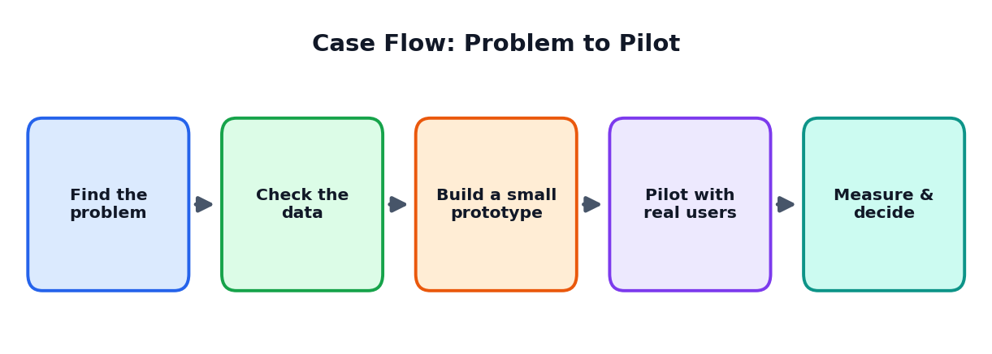
Figure 15.1: The common path followed in each case

Case Study 1: Anbu Clinic, a Neighbourhood Health Centre
PROBLEM
Patients wait a long time at reception, and many forget follow-up visits. Doctors spend much time writing notes instead of talking with patients.

IDEA AND DATA
- An appointment and reminder system that sends messages in the local language.
- A note-summary tool that turns the doctor's spoken notes into a draft that the doctor checks and signs.
- Data used: appointment records and consented, anonymised notes. Patient data is kept private.

PILOT AND RESULT
The clinic tests the reminder system for one month with one doctor. Missed follow-up visits drop and waiting time at reception reduces. Doctors say that note drafts save time but need correction, so they always review every note.

LESSONS
Privacy came first. AI saved time on routine work, while all medical decisions stayed with doctors. A small pilot with one doctor gave honest feedback before wider use.

Case Study 2: Kaveri Textiles, a Fabric Manufacturer
PROBLEM
Inspectors check fabric by eye, and tired eyes miss small defects. Some faulty rolls reach customers, causing returns and loss of trust.

IDEA AND DATA
- Cameras above the fabric line take photos while the cloth moves.
- An AI model is trained on thousands of photos labelled 'good' and 'defective' by experienced inspectors.
- Data quality: photos taken in the same lighting; labels checked by two inspectors to avoid mistakes.

PILOT AND RESULT
For two months, the AI and human inspectors check side by side. The AI catches many small defects, but sometimes marks harmless patterns as faults. Inspectors teach the system by correcting its errors. Returns from customers fall, and inspectors now focus on finding the cause of defects in the machines.

LESSONS
AI and humans together worked better than either alone. Good labels from experts were the key. The inspectors' roles changed from only checking to also solving root causes, so they were trained, not replaced.

Case Study 3: Green Valley Milk Cooperative
PROBLEM
Milk quantity varies each day with weather, season and festivals. Sometimes the cooperative has too much and milk is wasted; at other times it cannot meet demand from shops.

IDEA AND DATA
- A prediction tool that estimates daily milk collection and demand for the next week.
- Data used: three years of daily collection records, weather data, festival dates and shop orders.
- Data cleaning: missing days were filled by checking registers; units were made consistent.

PILOT AND RESULT
The manager uses the predictions to decide how much to convert into curd, butter and milk powder. In the first season, wastage is lower. During an unusual weather event the prediction is less accurate, so the manager learns to treat predictions as guidance, not as certainty.

LESSONS
Even simple prediction can reduce waste. Clean, consistent data mattered most. Human experience stayed important when situations were unusual.

Case Study 4: PageTurner, an Online Bookshop
PROBLEM
Customers find it hard to choose among thousands of books. Customer service staff are overloaded with questions on delivery and returns.

IDEA AND DATA
- A recommendation tool that suggests books based on what a customer has browsed or bought (with permission).
- A chatbot for delivery and returns questions, with a button 'Talk to a person'.
- Data used: purchase history, search words, common questions.

PILOT AND RESULT
The shop first shows recommendations to 10 percent of visitors and compares their sales with others (this comparison is called an A/B test). The group with recommendations buys more. The chatbot solves most delivery questions. Staff handle difficult cases and have time to call unhappy customers.

LESSONS
A/B testing gives proof, not guesses. Customers appreciated having a human option. The shop added a clear privacy note and an option to switch off personalised suggestions.

Case Study 5: City Bus Service Planning
PROBLEM
Some buses are overcrowded at peak hours while others run nearly empty. Passengers wait long at certain stops.

IDEA AND DATA
- A planning tool that studies ticket data and timings to suggest changes in bus numbers and times.
- Data used: anonymous ticket counts by stop and hour, route maps and traffic patterns.
- The planners also surveyed passengers, especially students and elderly people, so that data from machines was not the only voice.

PILOT AND RESULT
On two routes, the schedule is changed using the suggestions. Waiting times improve at busy stops. Passengers from a small village complain that a late bus was removed because few people used it, so the planners restore it as a social service and add a rule: 'Do not remove services that are essential for vulnerable groups, even if numbers are low.'

LESSONS
Data shows what happens, but not always what is fair. Humans must add values and care. Listening to the community improved the final plan.

Comparing the Cases
Case | AI task | Main benefit | Key human role
Anbu Clinic | Reminders, note drafts | Less waiting; saved doctor time | Doctor reviews and decides
Kaveri Textiles | Image recognition | Fewer faulty products | Inspectors teach and find causes
Green Valley Cooperative | Prediction | Less wastage | Manager judges unusual cases
PageTurner | Recommendation, chatbot | More sales; faster help | Staff solve difficult cases
City Bus Service | Optimisation | Shorter waiting time | Planners protect fairness

Your Final Project: The Innovation Challenge
Now it is your turn to be an innovator. Working alone or in a team of up to four, identify a real problem in an enterprise you can observe (a school office, a canteen, a local shop, a clinic, a farm, a bus stand or a small factory) and design an AI-supported solution. You will not need to build the AI itself. You will design the idea and test a simple prototype using paper, a spreadsheet, or a free tool.

Steps to follow
- Choose and observe. Visit the enterprise (with permission) and speak to the people there.
- Define the problem in one clear sentence and decide how success will be measured.
- Check the data. What data exists? Is it accurate, complete, current, consistent and fair?
- Generate ideas. Brainstorm at least ten ideas (you may use AI to help) and select one using a score table.
- Design the solution. Draw how it works: what the AI does and what humans do.
- Build a prototype. A paper model, a sample table or a simple sketch is enough.
- Test with real users. Collect opinions from at least five people.
- Check responsibility. Use the checklist: privacy, fairness, security, transparency, accountability.
- Calculate possible ROI with simple, honest estimates.
- Present. Prepare a 5-minute talk and a 6-page report.

Report contents
Page | Content
1 | Title, team names, problem statement and success measure
2 | What you observed; who the users are; their needs
3 | Data needed and how you will keep it good and safe
4 | Idea selection table and the chosen design (with a diagram)
5 | Prototype photos or drawings; test results and user comments
6 | Responsible AI checklist, ROI estimate and reflection

Assessment rubric
Criteria | 4 (Excellent) | 3 (Good) | 2 (Fair) | 1 (Needs work)
Problem understanding | Clear, real and well observed | Clear and mostly real | Somewhat vague | Unclear
Use of data | Well considered, quality and privacy covered | Data discussed | Little attention | Not considered
Solution design | Creative, clear human and AI roles | Clear design | Basic | Confusing
Testing | Real users, honest improvements | Some testing | Very little | None
Responsibility | All five pillars thoughtfully applied | Most pillars | A few | Not considered
Presentation | Confident, clear and organised | Clear | Unsure | Unclear

REFLECTION QUESTIONS
1. What was the most surprising thing you learned from users?
2. Which part of your project depends on AI, and which part depends on humans?
3. What could go wrong, and how have you reduced that risk?
4. If you had one more month, what would you improve first?

CHAPTER 16

Practice Questions
Test yourself and prepare for classroom assessments
HOW TO USE THIS CHAPTER
Try each question yourself first. Then check the answer key at the end of the chapter. Revise the sections for any question you missed.

Part A: Multiple Choice Questions (1 mark each)
Choose the correct option for each question.
Q1. Innovation means (a) only inventing a machine (b) turning a new idea into something useful that people use (c) copying others exactly (d) keeping ideas secret
Q2. Which is a process innovation? (a) A new smart watch (b) A factory using cameras to find faulty items quickly (c) A new company logo (d) A new office building
Q3. Renting a machine by the hour instead of selling it is an example of (a) product innovation (b) business model innovation (c) no innovation (d) a prototype
Q4. The first step of the innovation cycle is to (a) launch the product (b) spot a problem (c) stop testing (d) close the company
Q5. Which is NOT a way AI helps innovation? (a) Speed (b) Scale (c) Insight (d) Replacing all human judgement
Q6. An enterprise is (a) only a large factory (b) an organised group working for a purpose (c) a type of computer (d) a school bag
Q7. The department that hires and trains employees is (a) Finance (b) HR (c) Marketing (d) IT
Q8. A value chain shows (a) how value is added from raw material to customer support (b) the cost of a computer (c) a list of employees (d) only the sales numbers
Q9. Predicting how many products will sell next week is an example of AI doing (a) prediction (b) cooking (c) painting (d) typing only
Q10. Suggesting products to an online shopper is called (a) recommendation (b) inspection (c) deletion (d) printing
Q11. Sentiment analysis means (a) reading and summarising opinions in reviews (b) counting computers (c) repairing machines (d) painting walls
Q12. A chatbot should (a) never allow talking to a human (b) pass complex or upset customers to a human (c) hide that it is AI (d) refuse all questions
Q13. Predictive maintenance means (a) repairing only after a breakdown (b) repairing when data shows a problem is coming (c) never repairing (d) repairing on random days
Q14. Camera-based AI checking product quality is an example of (a) recognition (b) translation (c) payroll (d) advertising
Q15. In hiring, AI should (a) decide alone (b) assist while humans make final decisions (c) reject by age (d) read private messages
Q16. Fraud detection in a bank is mainly the job of (a) Marketing (b) Finance with AI alerts and human investigation (c) the canteen (d) the gate
Q17. Data that is organised in rows and columns is called (a) unstructured data (b) structured data (c) random noise (d) a prototype
Q18. Which is NOT a mark of good data? (a) Accurate (b) Complete (c) Outdated (d) Fair
Q19. 'Garbage in, garbage out' means (a) poor data gives poor results (b) AI cleans all garbage (c) data has no value (d) good data is not needed
Q20. The AI project life cycle starts with (a) deploying the model (b) defining the problem (c) monitoring (d) advertising
Q21. A pilot is (a) a small real-world trial before full launch (b) an aeroplane driver (c) the final product (d) a type of data
Q22. In design thinking, 'Empathise' means (a) understanding people and their problems (b) building the final product (c) selling it (d) ignoring users
Q23. MVP stands for (a) Most Valuable Player (b) Minimum Viable Product (c) Maximum Value Plan (d) Main Visual Page
Q24. Build-Measure-Learn is (a) a loop of making, testing and learning (b) a type of advertising (c) a computer virus (d) a bank rule
Q25. ROI = (a) (Benefit - Cost) / Cost x 100 (b) Cost x Benefit (c) Benefit + Cost (d) Cost / 100
Q26. Change management helps (a) people adopt new ways of working smoothly (b) delete all data (c) stop innovation (d) reduce salaries
Q27. Which is a pillar of responsible AI? (a) Secrecy of mistakes (b) Accountability (c) Speed only (d) Ignoring rules
Q28. Which data should NOT be pasted into public AI tools? (a) A textbook definition (b) Private customer details (c) A public holiday date (d) A general idea
Q29. A startup is (a) a new enterprise solving a problem in a new way (b) a very old shop (c) a type of calculator (d) a government form
Q30. The one-page plan includes (a) problem, solution, customers, value, income, costs and risks (b) only the logo (c) only the price (d) only photos

Part B: True or False
No. | Statement | Your answer
1 | Innovation is only about new machines.
2 | AI can help an enterprise predict demand.
3 | Hiring decisions should be left to AI alone.
4 | Good data should be accurate, complete, current, consistent and fair.
5 | A pilot is a small trial before full launch.
6 | Testing an AI solution is not needed if it looks good.
7 | Human-in-the-loop means a person reviews important AI decisions.
8 | ROI compares benefit with cost.
9 | Customers should never be told when they are talking to AI.
10 | AI will change some jobs and create new ones.

Part C: Fill in the Blanks
- Turning a new idea into something useful that people use is called ______.
- A new way of earning or delivering value is called ______ model innovation.
- The department that manages money is ______.
- AI that creates new text, images or music is called ______ AI.
- A small real-world trial before full launch is called a ______.
- Garbage in, garbage ______.
- A number that shows whether you are succeeding is a ______ (short form: KPI).
- ROI stands for return on ______.
- A person who starts and runs a new enterprise is an ______.
- A person who reviews important AI decisions keeps the human in the ______.

Part D: Short Answer Questions (2 to 3 marks each)
- Define innovation. How is it different from invention?
- Name and explain the four types of innovation with one example each.
- List the five steps of the innovation cycle.
- Explain how AI helps innovation through speed, scale, insight and creativity.
- What is an enterprise? Name any four kinds of enterprises.
- What is a value chain? Draw a simple one for a bakery.
- Give three examples of AI use in marketing or customer service.
- How does predictive maintenance work?
- Why must humans review AI decisions in hiring?
- Name the five marks of good data.
- List the six stages of an AI project life cycle.
- What is a prototype? How is it different from a pilot?
- State the formula for ROI and explain each term.
- Mention any four steps in helping people adopt AI at work.
- List the five pillars of responsible AI.

Part E: Long Answer Questions (6 to 10 marks)
- Explain the innovation cycle with a neat diagram and one example from a school. (8 marks)
- Describe how AI can be used in any three departments of an enterprise. (10 marks)
- Explain the five marks of good data and the journey from raw data to decisions. (8 marks)
- Describe the six stages of the AI project life cycle. Why is monitoring important? (10 marks)
- Explain design thinking with its five stages using an example. (8 marks)
- A shop spends Rs. 40,000 on an AI tool and gains Rs. 70,000 in a year. Calculate the net gain and ROI and explain two non-money benefits. (6 marks)
- Discuss the five pillars of responsible AI and the main risks of AI in enterprises. (10 marks)
- How are jobs changing due to AI? Suggest skills students should develop. (8 marks)

Part F: Application and Thinking Questions
- A small tea shop wants to use AI. Suggest three ways AI could help and one risk to avoid.
- A hospital wants AI to read patient records. List four rules the hospital should follow to protect privacy.
- A company wants to use AI to reject job applications automatically. Explain why this may be unfair and suggest a better method.
- Choose any problem in your town and apply the five stages of design thinking to it.
- Prepare a one-page plan for an AI startup idea that helps farmers or students.

Answer Key

Part A: MCQ answers
Q | Ans | Q | Ans | Q | Ans | Q | Ans | Q | Ans
1 | b | 7 | b | 13 | b | 19 | a | 25 | a
2 | b | 8 | a | 14 | a | 20 | b | 26 | a
3 | b | 9 | a | 15 | b | 21 | a | 27 | b
4 | b | 10 | a | 16 | b | 22 | a | 28 | b
5 | d | 11 | a | 17 | b | 23 | b | 29 | a
6 | b | 12 | b | 18 | c | 24 | a | 30 | a

Part B: True or False answers
No. | Answer
1 | False
2 | True
3 | False
4 | True
5 | True
6 | False
7 | True
8 | True
9 | False
10 | True

Part C: Fill in the blanks answers
1. innovation 2. business 3. Finance 4. generative 5. pilot 6. out 7. KPI (Key Performance Indicator) 8. investment 9. entrepreneur 10. loop

Parts D, E and F: Guidance
- For short answers, write 3 to 5 clear lines with key terms and one example.
- For long answers, use headings, a labelled diagram or table and end with a one-line conclusion.
- For question E6: net gain = 70,000 - 40,000 = Rs. 30,000; ROI = 30,000 / 40,000 x 100 = 75 percent.
- For application questions, many good answers are possible. Marks are given for clear reasoning, correct use of concepts and ethical thinking.
CHAPTER 17

One-Month Learning Plan
A week-by-week schedule for teachers and students
This plan suits about 4 to 5 sessions a week of 45 to 60 minutes each. Teachers may adjust it to their timetable.
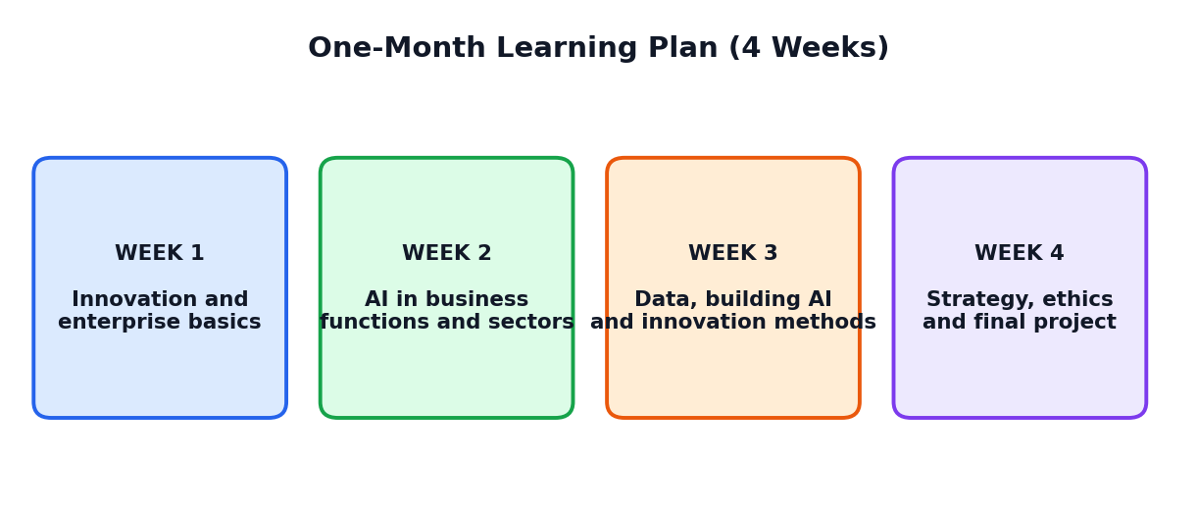
Figure 17.1: The four-week learning journey

17.1 Weekly Plan
Week | Theme | Chapters | Main activities
1 | Innovation and enterprise basics | 1, 2, 3, 4 | Spot problems; map an enterprise; AI use-case table
2 | AI in business functions and sectors | 5, 6, 7, 8 | Chatbot design; find the waste; fair or unfair; local problem list
3 | Data, building AI, innovation methods | 9, 10, 11 | Data detective; plan an AI project; mini design thinking
4 | Strategy, ethics, startups, project | 12, 13, 14, 15 | ROI practice; debate; one-page plan; Innovation Challenge

17.2 Session Guide
Week | Sessions | Student tasks
1 | 1: What is innovation?  2: AI and innovation  3: Enterprise and departments  4: AI use cases and maturity  5: Review quiz | Activities 1.1, 2.1, 3.1, 4.1
2 | 1: Marketing and customer service  2: Operations and supply chain  3: HR and finance  4: Sector snapshots  5: Review quiz | Activities 5.1, 6.1, 7.1, 8.1
3 | 1: Data and its quality  2: AI project life cycle  3: Design thinking  4: Prototype, pilot, KPIs  5: Review quiz | Activities 9.1, 10.1, 11.1
4 | 1: Strategy and ROI  2: Responsible AI and jobs  3: Startups and one-page plan  4: Project work  5: Presentations | Activities 12.1, 13.1, 14.1 and the Innovation Challenge

17.3 Assessment Ideas
Method | Marks (suggested) | What is assessed
Weekly quizzes (4) | 20 | Understanding of concepts
Activity notebook | 15 | Completion and quality of activities
Data Detective and AI Project Plan | 10 | Data and planning skills
Innovation Challenge report | 30 | Problem solving and design
Presentation and viva | 15 | Communication and honest explanation
Ethics and participation | 10 | Responsible attitude and teamwork

17.4 Self-Evaluation Chart
I can... | Not yet | Getting there | Confident
Explain innovation and its four types
Describe how AI helps innovation
Name enterprise departments and AI uses in each
Explain good data and the data journey
Describe the AI project life cycle
Use design thinking, prototypes and pilots
Calculate and explain ROI
Apply the responsible AI pillars

Glossary and Quick Revision
Key words in simple English
Term | Meaning
Innovation | Turning a new idea into something useful that people use
Invention | Creating something completely new for the first time
Prototype | A quick, rough model used to test an idea
MVP | Minimum Viable Product: the simplest working version for real users
Pilot | A small real-world trial before full launch
Enterprise | An organised group (business or institution) working for a purpose
Startup | A new enterprise solving a problem in a new way
Entrepreneur | A person who starts and runs a new enterprise
Value chain | Steps through which an enterprise creates and delivers value
Use case | A specific way a tool is used to solve a problem
Artificial Intelligence | Computer systems that perform tasks needing human-like intelligence
Generative AI | AI that creates new text, images, audio, video or code
Model | A trained AI system
Prediction | A guess about what will happen, based on data
Recommendation | A suggestion of what a person may like
Personalisation | Adjusting messages or services to each person
Sentiment analysis | Finding whether opinions in text are positive or negative
Predictive maintenance | Repairing machines when data shows trouble is coming
Automation | Machines or software doing tasks with little human effort
Data | Facts, numbers, text, images and sounds collected about something
Structured data | Data organised in rows and columns
Unstructured data | Data without a fixed table form, such as photos or emails
Bias | Unfair leaning for or against some people or ideas
Human-in-the-loop | A person reviews and decides important matters
Design thinking | A people-first method of solving problems
KPI | Key Performance Indicator: a number that shows success
ROI | Return on Investment: (Benefit - Cost) / Cost x 100
Change management | Helping people adopt new ways of working
A/B test | Comparing two versions to see which works better
Anonymise | Remove names and identity details from data

One-Page Quick Revision
INNOVATION AND ENTERPRISE
- Innovation = new idea made useful. Types: product, process, service, business model.
- Cycle: spot problem, ideas, prototype, test, launch and learn.
- Enterprise = organised group with a purpose; departments work together; value chain adds value.

AI IN THE ENTERPRISE
- Marketing and service: personalisation, chatbots, sentiment analysis.
- Operations: demand prediction, quality checks, predictive maintenance, routes.
- HR and finance: drafts, sorting, fraud alerts, with human decisions.
- AI tasks: prediction, classification, recognition, recommendation, language, generation, optimisation.

BUILDING AND MANAGING
- Good data: accurate, complete, current, consistent, fair.
- Life cycle: define, collect data, build, test, deploy, monitor.
- Methods: design thinking, funnel, prototype, MVP, pilot, build-measure-learn.
- ROI = (Benefit - Cost) / Cost x 100; adopt with explain, train, pilot, listen, expand.

ALWAYS REMEMBER
- Responsible AI: privacy, fairness, security, transparency, accountability.
- Keep humans in the loop for important decisions.
- Never share private data with public tools.
- Congratulations on completing the course book!

